**REPUBLIC OF KENYA**



**COUNTY GOVERNMENT OF NYAMIRA COUNTY**

**COUNTY SECTOR PLANS FOR GENERAL ECONOMIC,COMMERCIAL AND LABOUR AFFAIRS SECTOR**

**(2023-2033)**



**SECTOR VISION**

A nationally and globally competitive county economy with sustainable and equitable socio-economic development through promotion of trade, investment and enterprise development

**SECTOR MISSION**

To promote, co-ordinate and Implement integrated socio-economic policies and programmes for a rapidly industrializing, investing and entrepreneuring economy

**Foreword**

The Constitution of Kenya 2010, the Kenya Vision 2030 and its Medium Term Plans, provide the foundation for the preparation of the First Sectorial Plans for Nyamira County. This Sectorial Plan, will be used to inform resource distribution, a tool of resource mobilization in the face of limited and competing priorities for the betterment of the lives of the people of Nyamira County. The Kenya Vision 2030 is the country’s development blueprint covering the period 2008 to 2030. It aims to transform Kenya into a newly industrializing, middle-income country providing a high quality of life to all its citizens by the year 2030. The County’s vision of embracing urbanization for accelerated socio- economic growth is in tandem with this overall national vision. The Sector Plans identify a number of flagship projects to be implemented across the country for all sectors. The County Government has identified county-specific flagship projects and Programmes that will be implemented at county level and work with the National Government and Key Stakeholders to ensure these projects are implemented in a responsible, transparent and cost-effective manner. The preparation of this first Sector Plan is based on the County Governments Act, 2012 section 109 which mandates every county to prepare Sector Plans. The Sector Plan is a ten-year blue print that highlights the socio-economic challenges faced by the County, strategies for resources mobilization and programme interventions aimed at realizing our socioeconomic goals and desired impact. The preparation of the Sector plan was done through a participatory process that involved various stakeholders. The sector plan will provide a structured roadmap for planning, budgeting, implementation, monitoring, evaluation and reporting for programmes and projects within the sector over the ten-year planning period

**BERNERD MAINA**

**EXECUTIVE COMMITTEE MEMBER**

**DEPARTMENT OF TRADE ,INDUSTRILIZATION,TOURISM AND COOPERATIVE DEVEOPMENT**

**ACKNOWLEDGEMENTS**

The process of sector plan making is a consultative and participatory that consumes both financial and other resources The development process of this Sector Plan 2023-2033 was coordinated by the Excecutive Committee Member,Mr.Bernerd Maina.

We cannot list all by duty or contribution but we appreciate the commendable job done by; (CECM)Bernerd Maina,CCODennis Onduko,Director planning Paul Onyango,the economist Vane Bosibori,director trade,John Kerina,director tourism Grace Otanga,director weights and measures Kennedy Kilingungia, Economist Vane Nyasimi and the external stakeholders from SMEs.Their unwavering commitment and teamwork is duly acknowledged. Similarlly and with equal measure, I also express my appreciation to the entire Treasury staff and other sector conveners and co-conveners for their dedication, contributions and support that they provided during the preparation of this document.

We are particularly grateful to H.E the Governor His Excellency Amos Kimwomi Nyaribo, Deputy Governor His Excellency Dr James Gesami, the County Executive Committee Member for Finance and Economic Planning Mrs Emily Ongaga for their role, direction and guidance in developing this document.

I also take this opportunity to thank all Executive Committee Members, Chief Officers, Budget & Economic Forum members and all our partners for their invaluable contribution, either through direct or indirect support.

Finally, it is our sincere hope that the Nyamira Sector Plan 2023-2033would provide strategic guidance to the 2023/2024 annual budget.

Dennis Onduko

County Chief Officer

**DEPARTMENT OF TRADE ,INDUSTRILIZATION,TOURISM AND COOPERATIVE DEVEOPMENT**

**EXECUTIVE SUMMARY**

This Sector Plan is organised around six chapters. The first chapter covers basic introductory and background issues that are considered pertinent to the implementation of the Sector Plan. It also covers issues to do with sectorial development challenges, development agenda, sectorial resources and their contribution to the economy, sectorial Vision, Mission and Core Values, Departmental roles and lessons learnt from previous strategic plans. This Department is composed of Trade, Cooperative Development, Tourism, Investment and Industrialization. This strategic plan is a manifestation of the Department’s commitment to deliver quality services to the private sector, which is the engine of economic growth and development.

County Integrated Development Plan

This Sector Plan has been developed and anchored against the background of the Nyamira (2023-2027) CIDP. Through the stipulated initiatives and activities detailed in this plan, it is hoped that the department will be able to meet the challenges while ensuring the achievements of the Nyamira CIDP as well as fulfilling the aspirations of the national development blueprint, the Kenya Vision 2030. The plan identifies goals, objectives, strategies and activities, expected outputs and outcomes that the Department intends to pursue in the next five years. The plan is expected to accelerate economic growth and development by promoting trade, investment, industrialization, enterprise and private sector development.

Table of Contents

CHAPTER ONE: INTRODUCTION 11

1.1 Overview of the County 12

1.2 Background of the sector 14

1.3 Rationale for the County Sectoral Plan 15

Preparation of a County Sectoral Plan (CSP) it’s provided in the law that counties should prepare for the plans for easier running of programmes. The CSP are prepared for various reasons: 15

1.4 Approach/methodology in the preparation of the sector plan 16

CHAPTER TWO: PERFORMANCE REVIEW OF THE PREVIOUS CIDP PERIOD 17

2.0 Overview 18

2.1 Analysis of the County Revenue Sources 18

CHAPTER THREE: 34

SPATIAL DEVELOPMENT FRAMEWORK 35

3.0 INTRODUCTION 36

3.1 SPATIAL DEVELOPMENT FRAMEWORK 36

3.2 STATUS OF COUNTY PHYSICAL AND LAND USE PLANNING STATUS 36

3.3 COUNTY RESOURCE POTENTIAL GROWTH AREAS. 37

3.3.1 Physiographic Characteristics 37

3.3.1.1 Opportunities 40

3.3 Land and Land Use 57

3.3.1 Opportunities 57

3.3.2: Challenges 60

3.4 Environment and Natural Resources 60

3.4.1 Opportunities: 61

3.4.1 Opportunities 63

3.4.2 Challenges 67

3.5.1 Opportunities 68

3.6.1 Opportunities 71

3.7.1 Opportunities 71

3.8.1 Opportunities 75

3.8.2 Challenges 78

**3.10 Health** 84

3.10.1 Opportunities 84

3.10.2 Challenges 84

**CHAPTER 4: DEVELOPMENT PRIORITIES, STRATEGIES AND PROGRAMMES** 88

4.1.1 Sector Name: 89

Sector Priorities and Strategies: 89

4.2 Sector Programmes and Flagship Projects 94

4.2.1 Sector Programmes 94

4.2.2 Flagship Projects 102

4.3 CIDP Linkages with National Development Agenda, Regional and International 102

4.4 Cross-Sectorial Linkages 102

CHAPTER FIVE: IMPLEMENTATION FRAMEWORK 105

5.1. Overview 106

5.2. Institutional Framework 106

5.3 Resource Mobilization and Management Framework 108

5.3.1 Resource Requirements by Sector 108

5.5 Risk Management 110

CHAPTER SIX: MONITORING, EVALUATION AND LEARNING 111

6.2 County Monitoring and Evaluation Structure 112

6.3 M&E Capacity 113

6.4 M&E Outcome Indicators 113

6.5 Data Collection, Analysis and Reporting 114

6.6 Dissemination, Feedback Mechanism, Citizen Engagement and Learning 115

6.7 Evaluation Plan 115

ABBREVIATION

ACC-Assistant County Comissioner

CIDP-County Intergrated Development Plan

CSP-County Sectoral Plan

CECM-County Executive Committee Member

CS-County Sectretary

CCO-County Chief Officer

DCC-Deputy County Commissioner

FY-Financial Year

KEBS-Kenya Bureau of Standards

PWDs-People Living With Dissabilities

KNBS-Kenya National Bureau of Stastistics

UM-Upper Middle

MSEs-Macro and Small Enterprises

MTP-Medium Term Plans

LIST OF TABLES

Table 1 Analysis of County Revenue Sources 18

Table 2: County Expenditure Analysis 19

Table 3: Natural Resource Assessment 22

Table 4: Sector Development issues 23

Table 5: Sector Priorities and Strategies 90

Table 6: Sector Programmes 94

Table 7: Flagship Projects 102

Table 8: Cross-sectoral impacts 102

Table 9: Institutional Arrangement 107

Table 10: Summary of Sector Financial Resource Requirements 108

Table 11: Revenue Projections 109

Table 12: Resource Gaps 109

Table 13: Risk, Implication, Level and Mitigation Measures 110

Table 14: Outcome Indicator Reporting 113

Table 15: Evaluation Plan 116

LIST OF MAPS AND FIGURES

Figure 1 13

Figure 2 19

Figure 3 39

Figure 4 42

Figure 5 45

Figure 6 48

Figure 7 51

Figure 8 52

Figure 9 55

Figure 10 60

Figure 11 66

Figure 12 70

Figure 13 75

Figure 14 78

Figure 15 82

Figure 16 87

## 

## CHAPTER ONE

## INTRODUCTION

## 1.1 Overview of the County

Nyamira is situated in the Western part of Kenya. The County covers an area of 899.4km2. It lies between latitude 00 30’and 00 45’south and between longitude 340 45’ and 350 00’ east. It is indeed formed part of one of the divisions of the larger Kisii district way back in 1970s. In 1987, the Nyamira as a divisional boundary was created a district which has since existed with four constituencies. The coming of the devolution in 2013, Nyamira forms part of the 47 County Governments with one extra Constituency created and 20 electoral wards. The County Headquarter is located in Nyamira South Sub County, Township ward formerly the head-quarter for Nyamira District. It is located along Konate Junction Miruka Centre Road approximately six (6) kilometres from the Konate Junction, off the Kisii Chemosit Road

The County’s topography is mostly hilly *“Gusii highlands”*. The Kiabonyoru, Nyabisimba, Nkoora, Kemasare hills and the Manga ridge are the most predominant features in the county. The two topographic zones in the county lie between 1,250 m and 2,100 m above the sea level. The low zones comprise of swampy, wetlands and valley bottoms while the upper zones are dominated by the hills. The permanent rivers and streams found in the County include Sondu, Eaka, Kijauri, Kemera, Charachani, Gucha (Kuja), Bisembe, Mogonga, Chirichiro, Ramacha and Egesagane. All these rivers and several streams found in the County drain their water into Lake Victoria. The major types of soil found in the County are red volcanic (Nitosols) which are deep, fertile and well-drained accounting for 85 per cent while the remaining 15 per cent are those found in the valley bottoms and swampy areas suitable for brick making.

The County is divided into two major agro-ecological zones. The highland (LH1 and LH2) covers 82 per cent of the County while the upper midland zone (UM1, UM2 and UM3) covers the remaining 18 per cent. Although the vegetation in the County is evergreen, there is no gazetted forest. The county has a bimodal pattern of annual rainfall that is well distributed, reliable and adequate for a wide range of crops. Annual rainfall ranges between 1200 mm-2100 mm per annum. The long and short rain seasons start from December to June and July to November respectively, with no distinct dry spell separating them. The maximum day and minimum night temperatures are normally between 28.7C and 10.1C respectively, resulting to an average normal temperature of 19.4C which is favourable for both agricultural and livestock production.



The county has an estimated population of 653,515 as at 2022, with 336,407 being female and 317,108 males

Agriculture is the County’s economic backbone where 90% of its population is dependent on agricultural production and marketing directly and indirectly. It supports 80% of total employment opportunities in the county. Nyamira County lies in the Lake Victoria region, a region whose thirteen (14) counties have come together and formed the Lake Region Economic Bloc with the common understanding that strategic connections between Counties with shared interests seated in a desire for mutual benefit can be an effective and intelligent means of increasing the possibility of creating notable development impact across several counties. The Lake Region Economic Bloc is made up of Bungoma, Busia, Homa Bay, Kakamega, Kisii, Kisumu, Migori, Nyamira, Siaya, Vihiga, Bomet, Trans Nzoia and Kericho Counties.

The County has inter-county relations; along the Homabay County (Rachuonyo) border there is ethnic intermarriages, this is evident in Miruka and Nyamusi areas that has promoted peace coexistence. Miruka and Keroka markets along the borders of Homabay and Kisii counties respectively have promoted exchange of goods and services for the people living along these borders. The existence of the tea zones in Kericho and Nyamira counties has promoted employment among the tea factories and the dwellings.

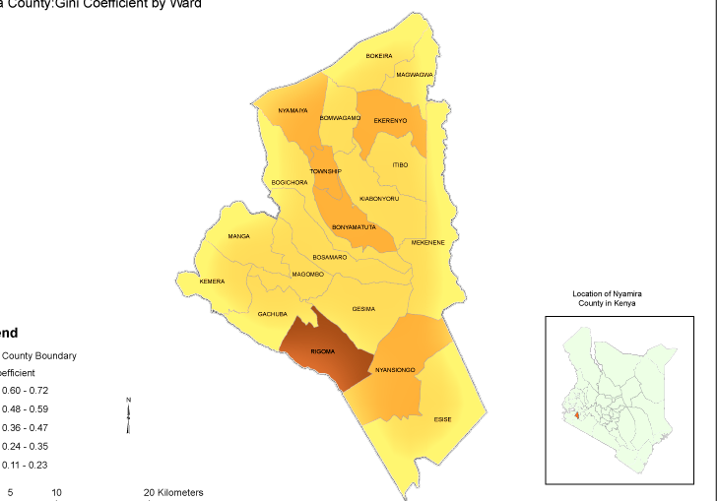

Figure 1

## 1.2 Background of the sector

**General Economic Commercial and Labor Affairs**

This sector consists of three sub-sectors namely: Trade, Co-operative and tourism development which is further broken down to Trade and Investments, Weights and Measures, Tourism development, Industrial development and enterprise development. The Sector commitment is to deliver quality services to the private and public sectors, which is the engine of economic growth and development. The Sector mandate is anchored on the Kenya Vision 2030 and County Integrated Development Plan (CIDP), which identifies strategies, goals, strategic objectives, activities, expected outputs and outcomes that the Sector intends to pursue within the period. It is expected to accelerate economic growth and development by promoting trade and investment, through creation of enabling environment for business to thrive.

**Sub-Sectors and Their Mandates Departmental mandate**

1. **Administration**

* Coordinate department programmes
* Ensures better service delivery

1. **Trade Sub sector**

The Directorate has been mandated to execute the following activities

* Market Infrastructure development and management
* Business regulation and revenue generation
* Fair trade practices and consumer protection
* Development of micro and small business
* Marketing and value addition
* Capacity building
* Promotion and development of Tourism
* Business financing

1. **Cooperative sub sector:**

The Directorate has been mandated to execute the following activities

* Marketing and value addition
* Cooperative audit services
* Mobilization of saving and credit provision
* Cooperative governance
* Capacity building
* Promotion of ventures

**D)Enterprise development**

* Market access through online platforms
* Technology acquisition and transfer of skills to MSEs
* Collaborate with relevant stakeholders to sensitize MSEs on work place environments
* provide workspace and common user manufacturing facilities
* promote agribusiness through value addition to agricultural products

**e)Tourism development**

* promotion of tourism through campaigns
* development of tourism
* coordination with public and private agencies
* plan and coordinate tourism

f**) Weights and Measures**

* To control the accuracy and manner of use of weighing and measuring equipment in use for trade.
* To control the sales and goods in terms of quantity.
* To regulate sales, manufacturing and the repairs of weighing and measuring equipment.
* To protect consumers against cheating through false trade description of goods and services in terms of quantity.

## 1.3 Rationale for the County Sectoral Plan

The Constitution of Kenya, 2010 created a two-tier system of governance, the national and devolved governments that are distinct but interdependent, each with specific functions as set out in fourth schedule of the constitution. County governments are required to prepare the County sector plans to enable prioritization of socio-economic development issues at the local level

Part XI of the County Governments Act, 2012 requires county governments to plan for the County. The Act requires that Counties prepare County plans including a ten-year County sector Plan. The Act prescribes that County plans should ensure harmony between National and County plans and that no government spending should be made outside the approved framework

### Preparation of a County Sectoral Plan (CSP) it’s provided in the law that counties should prepare for the plans for easier running of programmes. The CSP are prepared for various reasons:

* Easy resource allocation
* Provision of a forecast
* Setting of achievable goals
* Help in fast trucking of programmes to help achieve set targets

**LINKAGE OF SECTOR PLANS WITH THE KENYA VISION 2030**

Kenya’s Vision 2030 is an economic blueprint that seeks to create “a globally competitive and prosperous nation with a high quality of life by 2030”. The Vision aims to transform the country into a newly industrializing, middle-income country providing a high quality of life to all its citizens in a clean and secure environment. The Vision is anchored on three key pillars: economic; social; and political. Kenya Vision 2030 is implemented through successive five years Medium Term Plans (MTP) at the national level while the sector plans implement it at the county level

The section should provide a justification for preparing the CSP. This should entail discussing the need for the plan with reference to its linkages with: the existing national and county planning frameworks; and domestication of the relevant international obligations.

## 1.4 Approach/methodology in the preparation of the sector plan

Preparation of the secular plan involved a series of procedures. The department set the polies and guidelines on the preparation of the plans then the department of finance under the directorate of budgeting and planning issued a circular to all departments indicating the reasons for the preparations of the sectoral plans. The CECM(county executive committee member) finance gave the CS(county secretary) directive to issue the concept note. The plan was then launched by the governor to mark the beginning of the preparation of the plan.

After the launch, data collection process for the plan commenced. As required by the law, an advert was gazetted and advertised on radio stations to carry out public participation in order to collect views from the public on their preferred development issues. The public participation exercise was done by the appointed technical team which included the CECM, CCO, Directors together with planning team. The exercise was done through the ACC, DCC, Ward administrators, chiefs and sub-chiefs and this enabled data collection all the way from the village level. Data was therefore collected from all 20 wards in a span of one week.

A sector working group approach was therefore taken in order to retrieve data from all the directorates from both the county and national level. A technical team was again selected for this data collection process which involved directors from Trade, Co-operative development, Enterprise development, Weights and Measures and Tourism development and together they worked with the planners. The collected data from the sector working groups was thereafter reviewed by professional consultants to verify their credibility and accuracy.

The Finance and Economic Planning directorate then carried out a six day seminar with the Controller of Budget, KNBS official, County Physical Planner, Manager of Municipality and Regional Population Coordinator and together they came up with a zero draft copy of the plan. The plan was then uploaded on the county website and subjected to various stakeholders for stake-holders involvement.

## 

## CHAPTER TWO

## PERFORMANCE REVIEW OF THE PREVIOUS CIDP PERIOD

### 2.0 Overview

This chapter provides a review on implementation of the previous CIDP 2018-22. It presents an analysis of county performance in terms of revenues, expenditures and key outcomes as well as the major challenges faced in the implementation of the plan.

### 2.1 Analysis of the County Revenue Sources

This section should provide annual projected revenues versus actual receipts within the period under review. The information should be tabulated as in Table 11.

Table 1 Analysis of County Revenue Sources

|  |  |  |  |  |  |  |  |  |  |  |
| --- | --- | --- | --- | --- | --- | --- | --- | --- | --- | --- |
| **Rev enue Sources** | **Revenue Projection (Ksh. million)** | | | | | **Actual Revenue (Ksh. million)** | | | | |
| **FY1** | **FY 2** | **FY3** | **FY 4** | **FY 5** | **FY1** | **FY2** | **FY3** | **FY4** | **FY5** |
| a) Equitable Share | 124,717,277 | 47,137,690 | 62,070,065 |  |  | 108,872508 |  | 26,305,065 |  |  |
| b) Conditional grants (GoK) | 0 | O | 0 | 0 | 0 | 0 |  | 0 | 0 | 0 |
| c) Conditional grants  (Development  Partners) | 0 | 0 | O | 0 | 0 | 0 |  | 0 | 0 | 0 |
| d) Own Source Revenue | 15,631,793 | **34,281,378** | 34,281,378 |  |  |  |  | 34,281,378 |  |  |
| e) Other Sources (specify) | 6,433,488 | O | O |  |  | 13,178,258 |  | 34,116,279 |  |  |
| **Total** | 140,982,558 |  | 96,351,443 |  |  |  |  | 94,702,722 |  |  |

Figure 2

#### **2.2 County Budget Expenditure Analysis**

This section should provide an analysis of total budget allocation and total actual expenditure by sector. The information should be summarized as in Table 12.

Table 2: County Expenditure Analysis

|  |  |  |  |  |  |
| --- | --- | --- | --- | --- | --- |
| Sector: Economic, Commercial and Labor affairs | Total Budget  Allocation (Ksh in millions) | Total Actual  Expenditure (Ksh in millions) | Variance | Absorption  rate (%) | Remarks |
| 2018/2019 | 146,782,558 | 85,669,825 | -61,112,733 | 41.63% | Late release from the exchequer |
| 2019/2020 | 86,896,929 | 61,227,244 | 25,669,685 | 30% | Late release from the exchequer |
| 2020/2021 | 80,498,837 | 64,525,849 | 15,972,988 | 20% | Late release from the exchequer |
| 2021/2022 | 93,305,137 | 70,438,298 | -22,866,298 | 25.60% | Late release from the exchequer |
| 2022/2023 | 57,339,950 |  |  |  | Late release from the exchequer |
| Total | 464,823,411 | 257,418,635 | 125,621,704 |  |  |

*Provide a brief discussion on budget implementation performance based on variance between actual allocations versus actual expenditures (absorption rates by each sector).*

#### **2.3 Sector Programmes’ Performance Review**

**Trade**

In the plan period, the sector targeted to empower the county citizens economically. The sector was able to do so by constructing thirteen markets, constructing ten ordinary and one modern toilets in market places. It was also able to fence 9 markets and build one shoe polish shed. Furthermore, ten business sensitization forums were held, seven market committees established and eight traders training conducted. The sector also participated in an International Regional trade fair and seven local trade fairs. During the period, 13,250 businesses were invoiced and licensed.

**Co-operatives**

With the objective being to improve the returns on investments, good governance, member participation as well as improving investments and savings, the sector was successful in forming 8 new co-operative societies while reviving 5 of the same. Sixty statutory audit were conducted as well as six successful inspections done. The co-operative member training done proved to be of great importance in improving governance as 4 members compared to the planned 6 were retained.

**Weights and Measures**

Traders weighing and measuring equipment verified were 15,000 which was more than the planned figure (12,700). The sector also carried out 80 investigation and persecution of unfair trade practices and 85 on-site inspection of trade premises, Tea/Coffee Factories to ensure uniformity of weighing and measuring equipment. The sector also calibrated 120 fuel dispensing pumps.

**2.4 Challenges**

**Cooperatives**

|  |  |  |
| --- | --- | --- |
|  | **CHALLENGES** | **WAY FORWARD** |
| 1 | Inadequate funding | Upscale the budget during supplementary budget |
| 2 | Delay of prerequisite policy/legislation | the department is in the process of completing the formulation of policies and drafting relevant legislation i.e. the co-operative policy, County co-operative law, co-operative development fund bill |
| 3 | Inadequate technical staff | The department to expedite recruitment of the Technical staff |
| 4 | Inadequate means of transport | Procure at least one vehicle and repair existing one vehicle which is grounded |

**Industrialization**

1. Inadequate synergy levels between National and County Governments as well the private sector( KAM,KNCCI,KNJKFA,KEPSA etc)
2. Encroachment of public land earmarked for Industrial/MSE development
3. Low staffing levels
4. Lack of worksite management regulations
5. Unfavorable legal and regulatory framework
6. Limited access to affordable credit and financing
7. Limited market access
8. Inadequate worksites and industrial centers

**Trade**

During the implementation some challenges were faced. Some of these include:

* Lack of Policies and legislations. To manage markets, there was need for a document to give effect to constitution of committees and stipulate respective mandate. Lack of this resulted to several litigations.
* Disbursement of business loans was hindered as we lacked a legislation.
* Land encroarchment.This hindered fencing and construction of market facilities.
* Inadequate funding. The sector was poorly funded resulting to non-implementation of most projects.
* Frequent diversion of fund to other priorities from initial ones,
* Inadequate personnel. The sector is poorly staffed and as result performance is hindered.
* Inadequate working standards and tools
* Lack of goodwill and political interferences

#### **2.5 Emerging issues**

**C-operatives**

1. Arising from the experience of COVID19 the cooperative societies should adopt delegate system.
2. Succession management in the leadership of cooperative societies.
3. Gender mainstreaming in all levels of cooperative leadership.
4. Political interest in cooperative society leadership.
5. Increased demand for transparency in cooperative organization.

**Industrialization**

1. Adverse climate change effects
2. Cross cutting issues such as mainstreaming Gender,HIV/AIDS, the vulnerable and PWDs
3. Promote the use of ICT in MSME interventions
4. Adverse effects of pandemics like COVID 19 and Ebola

#### **2.6 Lessons Learnt**

**Industrialization**

1. Develop a benchmarking strategy.
2. Capacity building should be a continuous.
3. Need to have strong partnerships and collaborations with stakeholders in industrial and enterprise development.
4. Develop an effective monitoring and evaluation system to facilitate tracking of progress being made in the implementation of plan objectives.
5. There is need to mobilize provision of adequate resources to implement projects and programmes.
6. Put in place mechanisms to mitigate against calamities.

• Indicate the new knowledge gained during implementation of the previous CIDP, i.e. what worked and what did not work

#### **2.7 Natural Resource Assessment**

This section should discuss the major natural resources found within the county. The information should be summarized as indicated Table 3.

Table 3: Natural Resource Assessment

|  |  |  |  |  |  |  |
| --- | --- | --- | --- | --- | --- | --- |
| **Name of**  **Natural**  **Resource\*** | **Dependent**  **Sectors** | | **Status, Level of**  **Utilization;**  **Scenarios for**  **Future** | **Opportuniti es for optimal utilization** | **Constraints to optimal**  **utilization** | **Existing**  **Sustainable Management**  **strategies** |
| ***Manga ridge*** |  | * *Tourism* * Trade * Enterprise development | Land identified but not yet surveyed and demarcated  Construct of tourist park | *Best practices in promotion of local tourism that will help generate boost local revenue*  This will attract traders and MSEs to come up with structures to sell goods i.e kiosks | Land encroachment by the surrounding people hence | * *Land visitation for identifaction and survying* |
| Nkoora forest | ▫ | Tourism  Environment | ▫ trees planted and | *Can support people to embrace environmental conservation and hence curb climate changes* | *; deforestation by the surrounding people* | * *Legal and policy enforcement* * *Forest rehabilitation programme/planting more trees* |
| Kiabonyoru hiils |  | Tourism promotion | Land identified yet to be demarcated | Promote both local and national tourist | Land encroachment by the surrounding people | Legal policy enforcenment |

#### **2.8 Development Issues**

This section should present key sector development issues and their causes as identified during data collection and analysis stage. The information should be provided as indicated in Table 14.

Table 4: Sector Development issues

**Trade**

|  |  |  |  |  |  |
| --- | --- | --- | --- | --- | --- |
| **Major Issues/Problems** | **Causes** | **Development Objective** | **Immediate Objective** | **Existing opportunities/ strengths within the sector** | **Strategies** |
| **Trade Development** | | | | | |
| Inadequate Trade Development and promotion | Inadequate safe trading environment,  Poor hygiene environment  Poor governance in markets | Provide safe and hygiene trading environment  Better managed markets, | Increased safe trading environment  Improve management of markets | Adequate market space for construction relevant facilities  Existence of committees in some markets | Secure trading space by fencing markets,  Construct markets and market Sheds,  Open new markets,  Construct market Toilets to allow a hygiene environment,  Construction of0 warehouses,  Install lighting in markets,  Supply water to markets,  Open and improve access roads to markets,  Additional market days,  Market repairs,  Control of storm waters in markets,  Develop market management policies and other legislations.  Constitute market committees.  Conduct market committee elections |
| Inadequate business information and skills | Carry out business trainning | Improve business skills,  Avail business information,  Improve business records |  | Conduct business trainings to improve business skills,  Enhance sensitisation on business matters and opportunities,  Organize Investment forums,  Promote saving culture |
| Unregulated trade | A reliable traders data bank | Avail reliable traders data bank, | Available sketchy data,  Available annual finance Act | Conduct business mapping to ensure there is reliable data on businesses,  Licence all businesses,  Collect revenue from all businesses through Single Business Permits,  Review revenue rates i.e. SBP,market fee to make them affordable,  Enhance market due collections |
| Affordable Business finance | Provide traders with loans/funds |  |  | Develop legislation to provide loan kitty,  Give affordable loans to deserving businesses, |
|  | Participation in trade fairs and exhibitions | Equip clients with information and network | More business opportunities and access to market of local products |  | Identify participants for various exhibitions,  Explore relevant exhibition for participation by officers and traders,  Participate in identifying products to be exhibited, |
|  |  |  |  |  |  |

**Co-operatives**

|  |  |  |  |  |  |  |
| --- | --- | --- | --- | --- | --- | --- |
|  | **Major Issues/Problems** | **Causes** | **Development Objective** | **Immediate Objective** | **Existing opportunities/ strengths within the sector** | **Strategies** |
|  | **Cooperative Development** | | | | | |
| 1 | Inadequate Credit facility to  Co-operative societies | Low savings among membership,  Weak coordination and linkages among Cooperatives    Inadequate training of Cooperative society leaders.  Weak Monitoring and evaluation of programmes. | Empowering Co-operative societies | Increased awareness on cheap credit facility.  Strengthening of loaning policy    Adequate training of management committees  Strong Monitoring and evaluation system developed | Existing laws, policies and regulations.  Preparation of County cooperative policy, County Cooperative Act,  County Enterprise development Fund Act | Train all the management committee.  Initiate cooperative Information Management System (CIMS)  Enforcement of relevant laws, policies and regulations  Creation of Cooperative revolving fund |
| 2. | Poor Governance in the  Co-operative movements | Weak loaning policy in cooperatives  Weak Human resource policy  Dormancy of cooperative society  Ageing membership in cooperative societies  Inadequate training  Audit arrears  In adequate technical staff,  Low level of training of cooperative society staff  Low level of cooperative society products  Low level of utilizatio  n of ICT | Compliance of Co-operative societies | Increased regular training of cooperative leaders and staff  -Gender mainstreaming in cooperative society leadership  -increased cooperative society products  Increased number of departmental technical staff | Adherence to cooperative society Act  Utilization of existing booking centres | Holding seminars, workshops and exchange visits  Board meeting  Regular inspections  Regular statutory audits,  Regular Spot checks  Preparation of County cooperative code of conduct  Conducting Co-operative societies elections |
| 3. | Underdeveloped marketing channels | Inadequate processing facilities  Low utilization of digital machines | Marketing Development | Purchase of processing and digital machineries | Availability of raw materials.  Utilization of existing processing machine eg Gusii coffee union milling plant | Enhance communication among all stakeholders  Initiate cooperative  Information Management System (CIMS  Formation of Co-operative bulking centres |

**Industrialization**

|  |  |  |  |  |  |  |  |  |  |
| --- | --- | --- | --- | --- | --- | --- | --- | --- | --- |
| **Major Issues/Problems** | **Causes** | **Development Objective** | | **Immediate Objective** | | **Existing opportunities/ strengths within the sector** | | **Strategies** | |
| **Industrial/MSE Development** | | | | | | | | | |
| Low levels of industrialization | Lack of awareness on intervening programs | | -To attract local and foreign industrial investment  -Promote value addition in the counties  -Generate employment opportunities  -Improve product competitiveness and business environment | | -Create awareness on value addition, standardization, product development and IPRs.  -Promote linkages to relevant supporting institutions  -Introduce trainings targeting tanneries and manufactures of leather products  -organize shows/exhibitions and investment forums  -Initiate procurement of tools and equipment such as vegetable drying machines, lathe machines, carpentry, welding, vehicle mechanical tools etc | | -Existing offices of Industrialization, Enterprise Development, KIRDI, KIE, KEBS in the region with qualified staff  -availability of primary products for value add  -existence of the industrialization policy | | -Conduct training needs analysis from which we derive areas of training eg marketing, value addition, record keeping  -Mobilize the relevant supporting institutions like KIE, KEBS, KIRDI, KIPI etc to disseminate information on their products and services on the ground.  -Hold exhibitions modelled under One Sub County One Product  -Provide specific tools and machines to entyrprneurs and innovators based on strengths from a particular area cluster.  -Build worksites and industrial development centres in each Sub County  . |

**Weights and Measures**

|  |  |  |  |  |  |
| --- | --- | --- | --- | --- | --- |
| **Major Issues/Problems** | **Causes** | **Development Objective** | **Immediate Objective** | **Existing opportunities/ strengths within the sector** | **Strategies** |
| **Consumer protection** | | | | | |
| Unfair trading practices and false trade description | Lack of awareness of laws and regulations control controlling fair trade practices,  Intentional fraudulent use of weighing and measuring equipment by traders,  Use of illegal weighing and Measuring equipment’s | Create and ensure a level playing field that facilitates fair competition in trade transaction involving quantity measurement.  Ensure use legal weighing and measuring equipment’s  Increased inspection activities | Increase training of traders on existing laws and regulations governing fair trade practices.  Increase sensitizations of consumer rights | Existing laws such as weights and measures Act Cap 513, Trade description act Cap 505, consumer protection Act cap 46, 2019  Fair trade regulation and competition laws of kenya | Train traders on fair trading practices,  Sensitize consumers their rights,  Enforce the existing laws and regulations by conducting regular inspection of traders premises  Carry out verification of traders weighing instruments |
| Use of unapproved weighing and measuring equipment for trade use,  Lack of regular inspection of manufacturing, sales and repairs of weighing and measuring equipment for trade use,  Inadequate of physical standards of weights and measures which are nationally and internationally recognized,  Lack of regular calibration of working standards.  Wear and tear of working standards    Counterfeit goods | Ensure promotion of uniformity of all weighment and measurements in trade through procurement and maintenance of physical standards of weights and measures. | Ensure traders use approved weighing and measuring equipment, | Existing laws such as weights and measures Act Cap 513, Trade description act Cap 505, consumer protection Act cap 46, 2019  Fair trade regulation and competition laws of kenya | Examine, test and stamp weighing and measuring equipment in use for trade,    Certify weighing and measuring equipment,  Carry out inspection on persons selling and repairing weighing and measuring equipment.  Carry out bi-annual calibration of standard in compliance with primary national standard |
| Ensure all goods and services offered for sale bears accurate description | Increase awareness on consumer rights. | Existing laws such as weights and measures Act Cap 513, Trade description act Cap 505, consumer protection Act cap 46, 2019  Fair trade regulation and competition laws of Kenya, other existing state departments such as KEBS, Competition Authority of Kenya | Sensitise the consumers,  Conduct regular inspection of traders premises, collaborates with other relevant state department to enforce trade description Act |
| Manipulation of weighing and measuring equipment for trade use,  Having in possession an inaccurate weighing and measuring equipment for trade use,  Having for trade use unapproved weighing and measuring equipment,  The trader fails to submit the weighing and measuring equipment in his/her possession for verification and stamping by weights and measures officer. | Continuously ensure all weighing and measuring equipment for trade use are accurate, | Maintain accuracy of weighing and measuring equipment in use for trade, | Existing laws such as weights and measures Act Cap 513, Trade description act Cap 505, consumer protection Act cap 46, 2019  Fair trade regulation and competition laws of kenya | Examine, verify, stamp and certify the weighing and measuring equipment the trader is using,    Examine, verify, stamp and certify the weighing and measuring equipment the trader is using,    Carry out the investigation of complain pertaining fraudulent use of weighing and measuring equipment.  Prosecute the trader infringing laws and regulations governing trade. |
|  | Low revenue collection | Improve revenue collection | Certify all weighing and measuring equipment in use for trade within the county | Existing laws such as weights and measures Act Cap 513, Trade description act Cap 505, consumer protection Act cap 46, 2019  Fair trade regulation and competition laws of Kenya, Nyamira County finance Act 2021 | Certify all weighing and measuring equipment in use for trade,  Regular inspections of weighing and measuring equipment in use for trade.  Procure weights and measures working standards and tools. |

**Tourism**

|  |  |  |  |  |  |
| --- | --- | --- | --- | --- | --- |
| **Major Issues/Problems** | **Causes** | **Development Objective** | **Immediate Objective** | **Existing opportunities/ strengths within the sector** | **Strategies** |
| Undeveloped  d and poorly  maintained  tourist  attraction  Sites.  -Poor  accessibility to  the tourist  places  -Lack of  adequate  facilities in the  tourist  attractions  Undemarcated land in major tourist sites | In adequate  Funding | To promote  tourism  development | To develop and  market tourism  attraction sites  by 2027 | Existence of partners such as tourism board | -Marketing and  branding of  tourist attraction  sites  Diversification  of tourism products;  Development, maintenance  and adequate  financing of tourist  attraction sites  -Provide adequate  facilities at the tourist  attractions sites  -Harnessing Agri  Tourism, Eco  Tourism and Conference  Facilities  **Surveying and demarcate the sites to avoid encroachment** |

# 

# **CHAPTER THREE**

# **SPATIAL DEVELOPMENT FRAMEWORK**

## 3.0 INTRODUCTION

This section, describes the spatial framework within which development projects and programs will be implemented, establishing a broad physical and Land Use Planning framework that provides spatial planning policies to support economic and sectorial planning.

# 3.1 SPATIAL DEVELOPMENT FRAMEWORK

The County Government of Nyamira‘s transformative agenda is anchored on socio-economic transformation aimed at ensuring that the quality of life is improved throughout the County. This transformative agenda sets outs the blue print for economic growth that covers all strategic development areas within the County. This vision can only be achieved if the development is anchored in sound GIS based Physical and Land Use Planning. As such, the Vision lays emphasis on spatial reforms, with the preparation of the County Spatial Plan and various areas Local Physical Development Plans.

The role of Land use planning and indeed the CSPs is explicitly outlined in the Constitution of Kenya Article 61 and 66, further County Government Act of 2012 which under section 110 (1)(a) stipulates that the County Spatial plans shall give effect to the principles and objects of planning and development contained in section 102 and 103 of the same Act. It also outlines that the CSPs should set out the guidelines for a land use management system in the County.

As espoused in the Physical and Land Use Planning Act of 2019, the preparation and implementation of the CSP will set the momentum for prudent utilization of County space, resources and inter-ministerial coordination. Further, the plan will facilitate the achievement of the land policy principles of efficiency, equity, sustainability and productivity, and promote the attainment of social, economic and environmental goals and objectives. Further, the Plan provides strategies and policies to deal with challenges including urbanization, regional imbalances/inequalities, rural under-development, environmental degradation, and underutilization of the massive resources available in the country.

The policy framework that the preparation of the CSP alludes to include; Sustainable Development Goals, New Urban Agenda, The Kenya Vision 2030, Medium Term Plans, Urban Land Use Planning and Oversight guidelines, national land use policy, national urban development policy, national spatial plan among others.

## 3.2 STATUS OF COUNTY PHYSICAL AND LAND USE PLANNING STATUS

Since the enactment of the Physical and Land Use Planning Act and establishment of the Nyamira Municipality, through the Planning authority, the Physical and Land Use Directorate, the County has prepared Nyamira Municipality Spatial plan to preparation of the final report, subject to the County Executive Committee Members ratification, County assembly approval to the eventual ascent by H.E the County Governor of Nyamira. Alongsie the MSP, the Planning Authority have prepared 9 Local and Physical Development Plans for major urban centers within Nyamira Municipality. The towns include, Nyamaiya, Miruka, Kioge, Nyamira Township, Sironga, Konate, Kebirigo, Ting’a and Nyaramba.

It shall be noted that the county has more than 70 upcoming urban centers with either have outdated plans or no plans and notably require urgent planning intervention to ensure coordinated development and appropriate sustainable investment for the prosperity of the people of Nyamira. This shall be given priority at the completion of the CSP strategic urban areas spatial and institutional development for wealth creation. The County Spatial Plan 2022-2032, after completion of the Inception Report, The situational Analysis Report, is at its third stage of Draft Plan Formulation before preparation of the Final Plan report for approval consideration stage.

## 3.3 COUNTY RESOURCE POTENTIAL GROWTH AREAS.

The CSP of the Situational Analysis of the economic systems is prudent for the understanding of human interactions, growth and development of an area. Kenya’s Vision 2030 is founded on the economic, social and political pillars. Being one of the pillars identified to guide the national agenda, the economy is therefore integral to any region’s growth and development. Accordingly, Nyamira County has a rich economic base founded on agriculture, mining, tourism and hospitality, agro-based industries as well as trade and commerce. The forgoing shall transform the County wealth and economy through focus on specific thematic identified and highlighted hereunder for modelling.

### 3.3.1 Physiographic Characteristics

Physical features play a critical role in the county development. Some of the features like rivers, wetlands, forests/hills and water falls are sources of livelihoods to the county residents. The county physiographic characteristics present both opportunities and challenges as outlined below:

**Map 3. Natural Features**

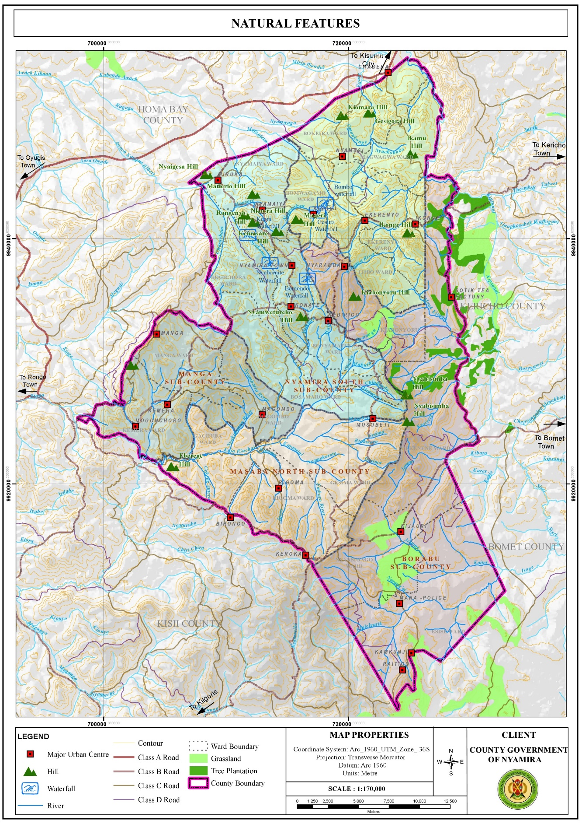

Figure 3

### 3.3.1.1 Opportunities

1. Hydrology: The County is adequately drained by the four main rivers and their tributaries. There are also several springs, wetlands and few water falls which sustain the county’s hydrological cycle. In addition, the high-water tables in the county have enabled the digging of shallow wells and boreholes. These water resources are the main water sources in the county, for instance, the intake for Nyamira water supply is located at River Eaka. River Sondu on the other hand has a lot of potential for hydro-electricity power generation which if tapped could contribute greatly towards the economic development of the county. The presence of numerous rivers presents opportunities for water harnessing through river obstruction.
2. Favorable Climatic Conditions for Agricultural Activities: The county has a bimodal pattern of annual rainfall that is well distributed, reliable and adequate for a wide range of crops with annual rainfall ranging between 1200 mm – 2100 mm per annum. The cold temperatures in the county are ideal for the growth of certain crops like tea and coffee which grow better in relatively cold regions.
3. Suitable Ecological Zones and Fertile Volcanic Soils for Agricultural Activities: The county is divided into two major agro-ecological zones. The highland zone (LH1 and LH2) covers 82 per cent of the County while the upper midland zone (UM1, UM2 and UM3) covers the remaining 18 per cent. These zones are suitable for growing various crops among them; tea, coffee, bananas, maize, avocado, sugarcane, pineapple, sweet potato, pyrethrum etc. These suitable ecological zones coupled by the rich volcanic soils make the county one of the main food producers in the country exporting food commodities to the regional hinterland and the country’s capital. However, the economic viability of the agricultural sector is threatened by the diminishing land sizes resulting from unregulated subdivision mainly for inheritance purposes.

**Map 4. Agro-Ecological Zones**

Figure 4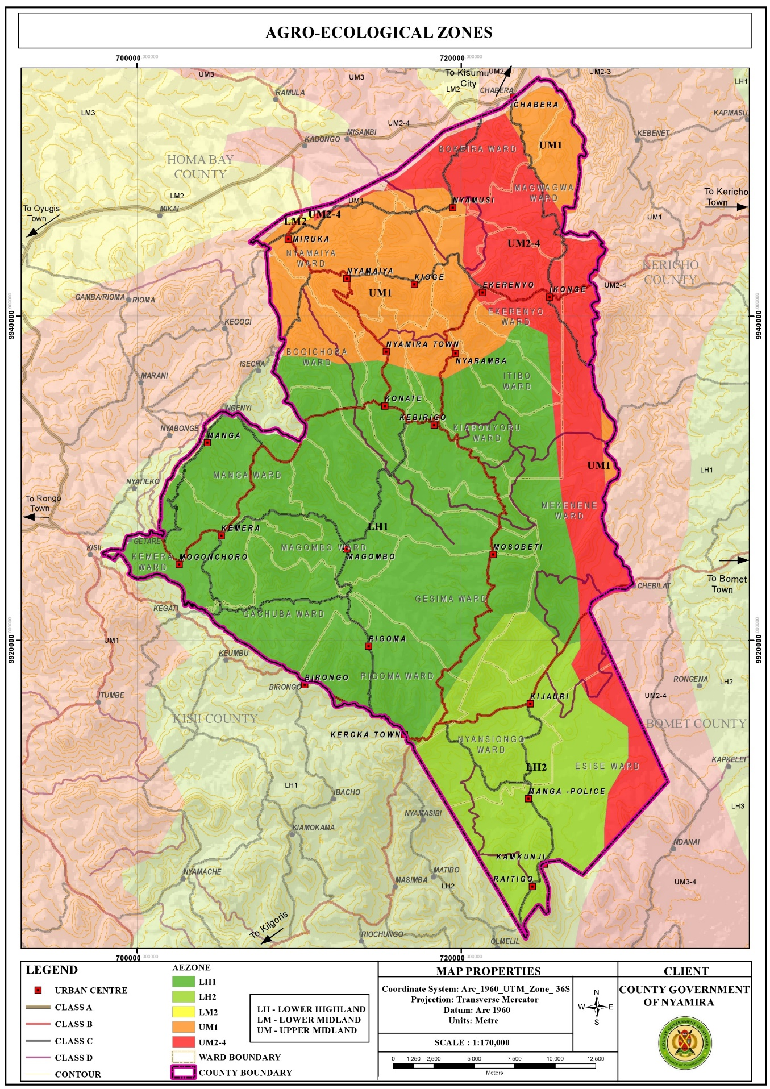

1. High Rainfall Amounts: The high rainfall patterns of between 1200 mm – 2100 mm per annum present opportunities for rain water harvesting through creation of large-scale runoff collection reservoirs and household rainwater harvesting. The harnessed water would be used during the relatively dry seasons of the year. If the harnessing is optimally undertaken, it would augment the terrain problems associated with piped water provision. Moreover, the rain water would reduce pressure on the natural water resources like springs, streams, rivers and wells which together supply water to about 80% of the population.

**Map 3. Rainfall Distribution Map**

Figure 5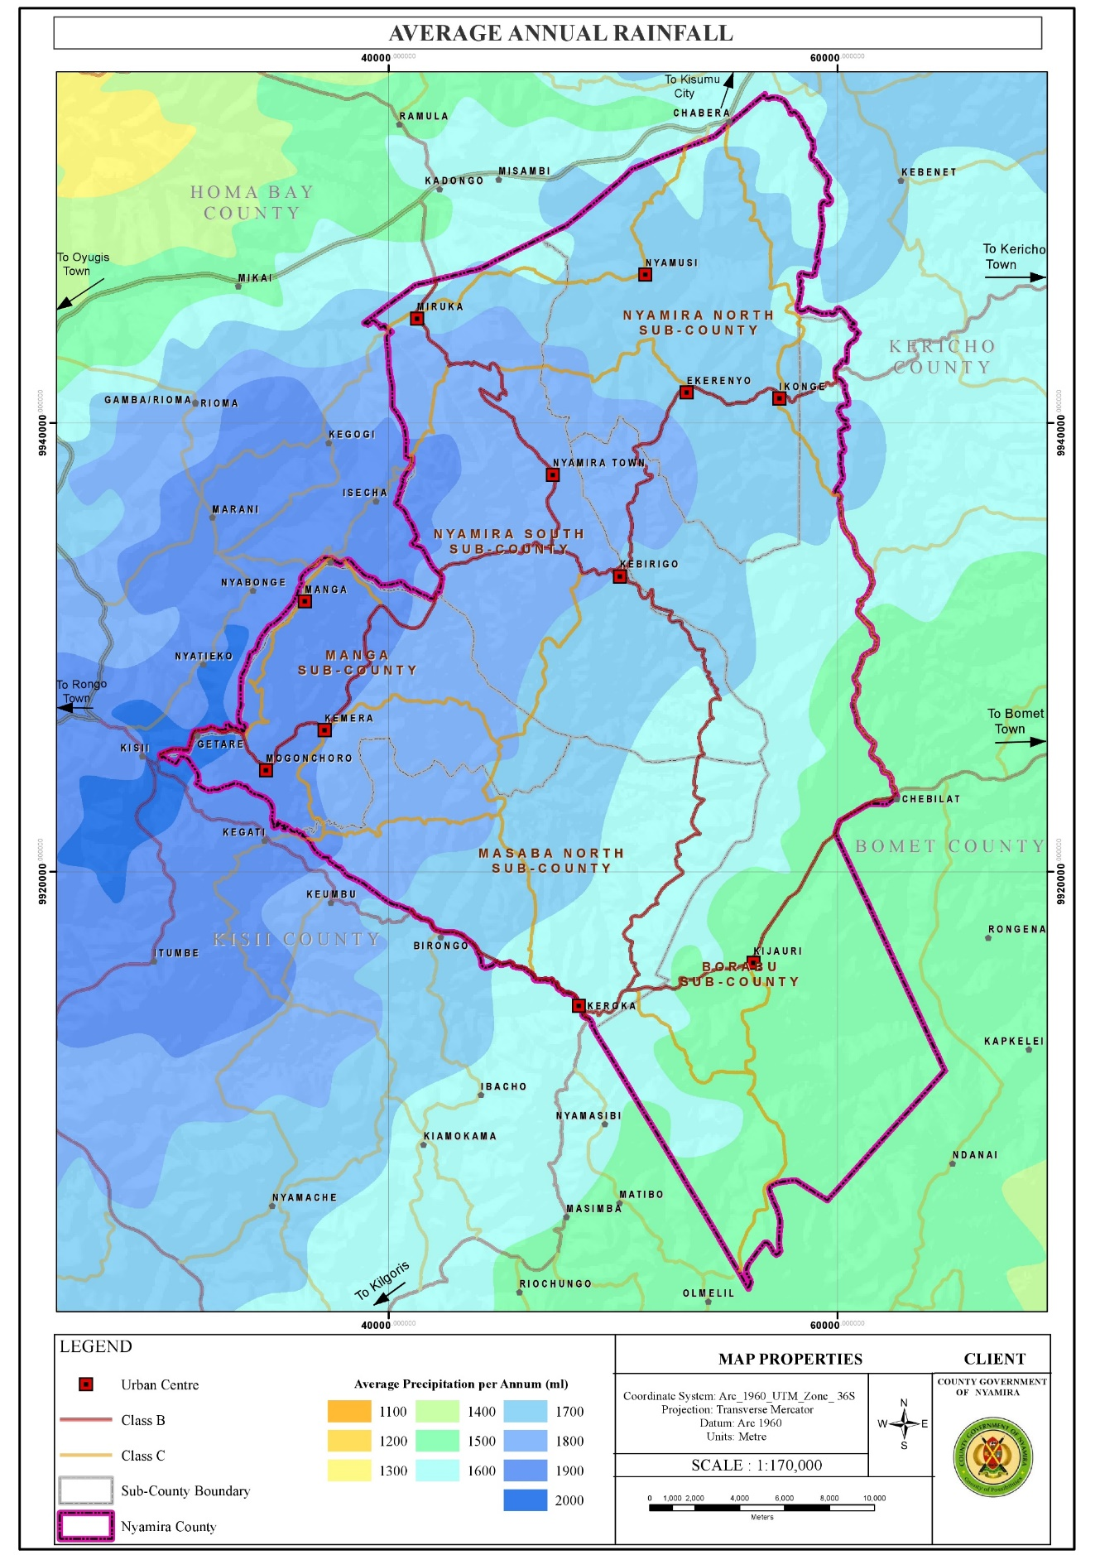

1. Renewable Energy: Harnessing like solar and wind though in small scale Nyamira County is relatively cold. However, the northern part of the county comprising of areas around Miruka, Nyamusi and Chabera have high solar potential with an annual solar photovoltaic power potential of between 1691 -1710 kWh/kWp. These areas also are the hottest with temperatures of 21.10C – 21.50C. The high temperatures in the northern part of the county coupled with high solar potential present an opportunity for solar power generation even at the household level. The county has an average wind speed of 2.46m/s which is beyond the cut-in-speed for small turbine to start generating energy which is set at 2m/s. However, the wind potential in the larger county is not at the required maximum of 10-15m/s with the exemption of the area around Manga ridge, an area near Birongo Market Centre in Masaba North Sub-County and an area near Ekerenyo Market Centre in Nyamira South Sub-County with relatively high wind power density of between 301 - 400 Watts per Square Metre. This wind power could be tapped to produce electricity.

**Map 4. Solar Potential Map**

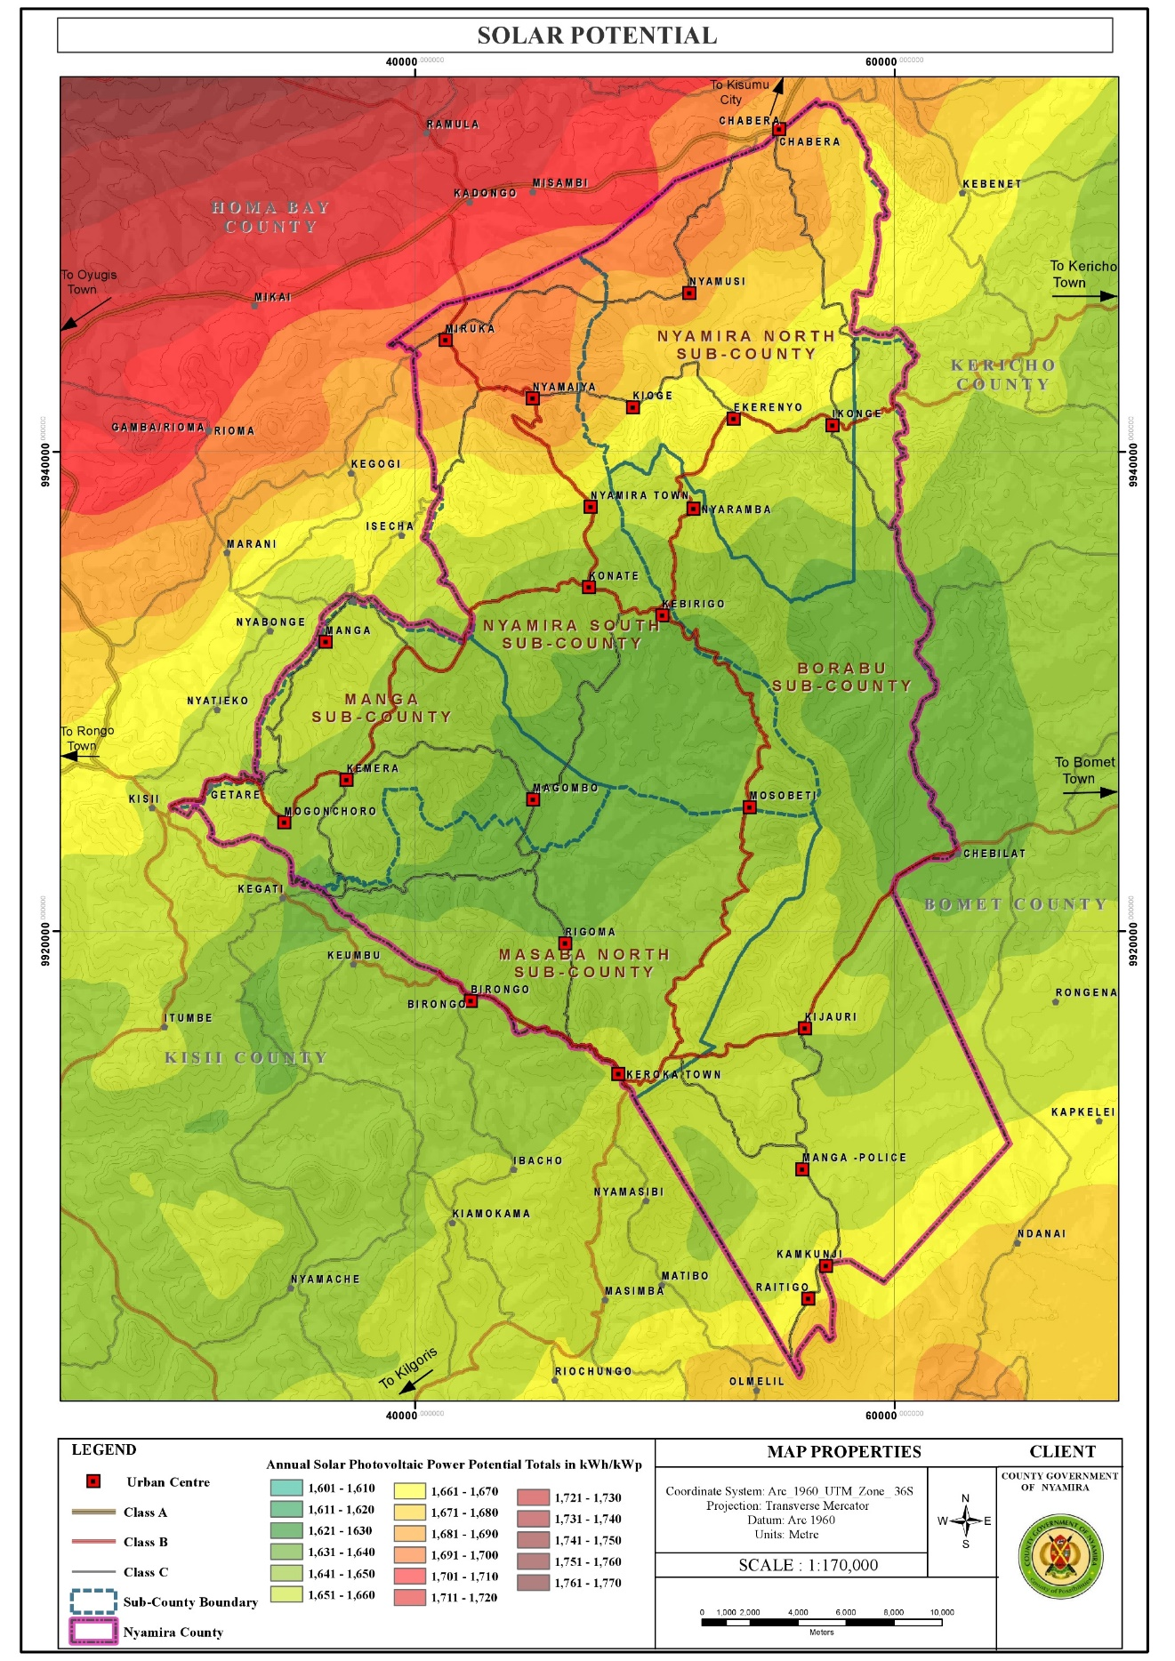

Figure 6

**Map 5. Temperature Distribution Map**

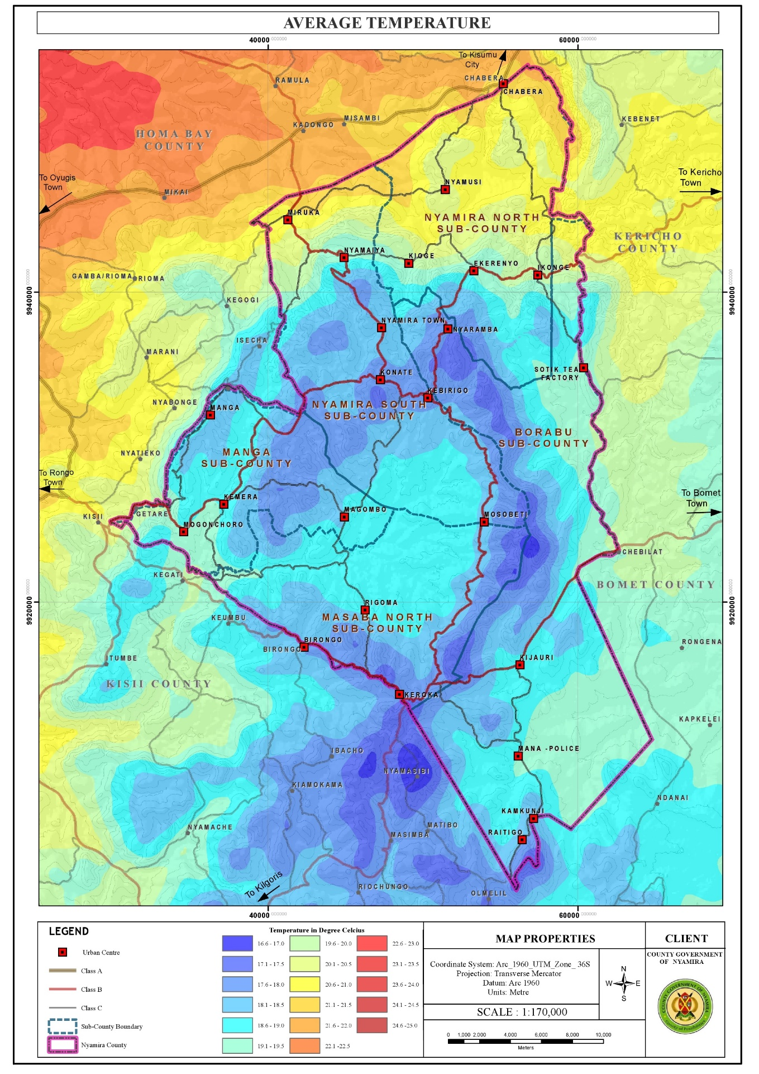

Figure 7

#### 3.3.1.2 Challenges

1. Depression of Water Levels: The water levels in the rivers, springs, streams and waterfalls have been depressing over time a phenomenon attributable to several factors among them, planting of inappropriate tree species along the riparian reserves and water catchment areas, improper farming methods, unregulated water obstruction upstream and the negative effects of climate change. These factors have resulted to reduction of water levels in the main rivers and drying up of the streams.
2. Unfavorable topography for construction: The rugged terrain in the county makes some areas inaccessible as construction of roads to certain places especially those on the hilly areas or low lands is an expensive undertaking. In addition, piping of the water from the various water sources in the low lands to the majority of the homesteads in the hilly areas is very costly, rendering it unfeasible. This forces the residents to access the water from their natural sources (springs and rivers).

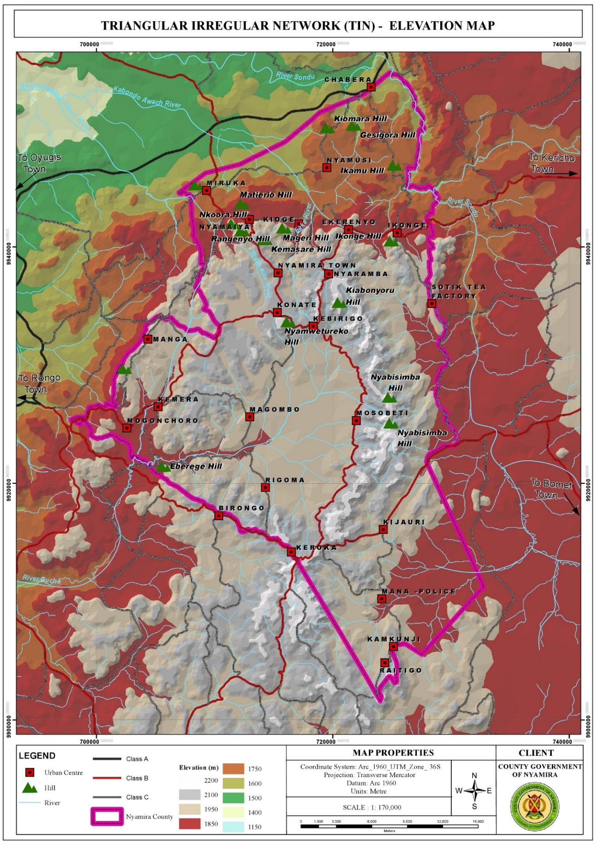

Figure 8

1. Poorly Drained Soils in Some Areas Resulting to Constrained Developments: A few areas in the county have poorly drained soils. These areas include sections of Magwagwa, Township, Bogichora, Bosamaro and Gesima Wards. They are characterized by red volcanic soils which are good for farming but make construction and road maintenance expensive. Thus, these areas are constrained in achieving high density developments.
2. Soil Erosion: Most of the rivers are characterized by brown waters, an evidence of soil erosion upstream. Soil erosion which displaces the fertile upper layer of the soil has negative implications on farm productivity as it results to reduced soil fertility. o High rainfall amounts The high rainfall amounts in the county coupled by increase in impervious layer make the county susceptible to flooding. The built areas especially those in the low lands face floods while the steep areas are susceptible to landslides especially in areas with loose soils.
3. Changing Weather Patterns: Changing weather patterns have affected all development sectors in the county with agriculture being the worst hit. The notable effects of this change are; delayed onset and untimely cessations of rain, skewed rainfall distribution and intensity and emergence of new pests and diseases.

**3.3.2 Population and Demography**

Population and demographic characteristics have far reaching implications on the county’s development. Various age cohorts present different needs with young population requiring the establishment of educational and health facilities. Youthful population requires focusing on youth empowerment programmes for skills and talent enhancement. To absorb the increasing labor force, investments in modern agricultural production and agro-based industries is necessary. The aged population on the other hand calls for allocation of resources for the provision of basic needs like water, food, clothing, shelter and medical services. The opportunities and challenges facing the county population are outlined below:

**Map 7. Population Density Map**

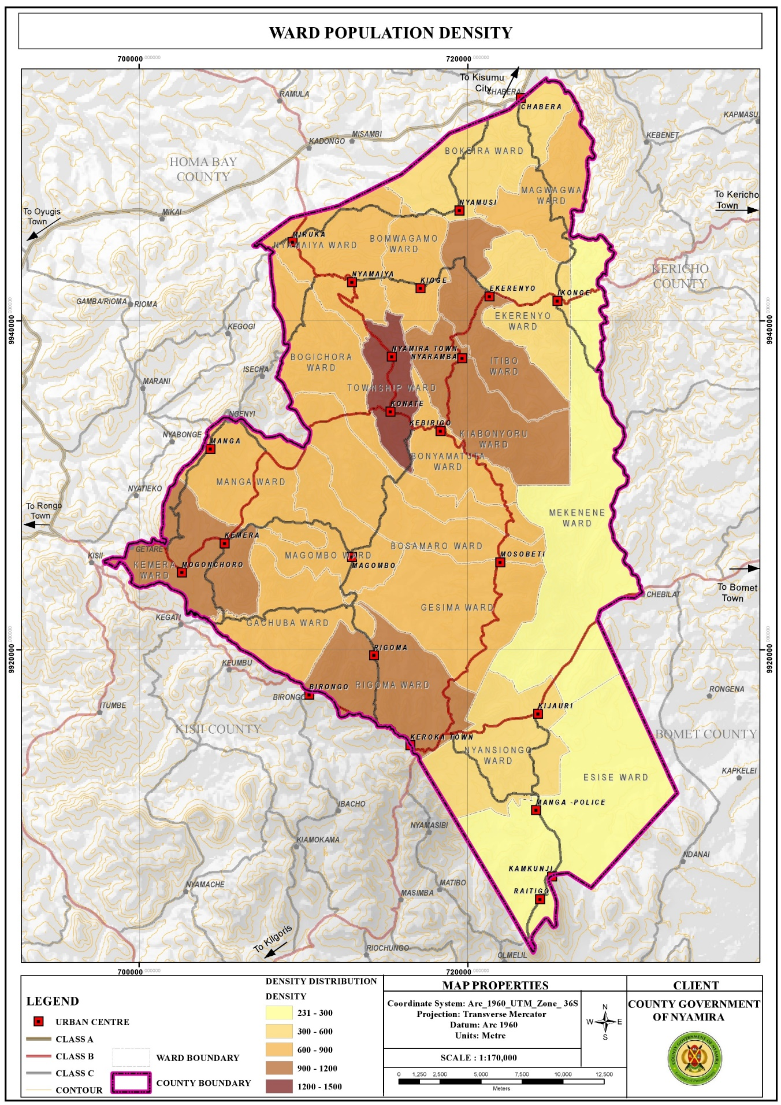

Figure 9

#### 3.3.2.1. Opportunities

1. High proportion of Youthful Population: The youthful population constitutes the largest segment of the county population as 72.44% is under the age of 35 years. The youths (15-35 years) in the county account for about 33.3% of the county population. This population requires massive investment in skill development. This presents opportunities for youth empowerment programmes for skills and talent enhancement.
2. High proportion of labor force: The labor force (15-64 years) constitutes about 55.8% of the total population. This calls for investment in diverse sectors like modern agricultural techniques and agro-based industries as well as creation of self-employment opportunities so as to absorb the increasing labor force
3. Development of Special Programmes : To address the needs of the elderly The aged population (65+ years) constitutes about 5% of the county population. This population presents opportunities in the provision of basic needs like food, water, clothing, shelter and health services so as to cater for the needs of this age group. In addition, this group presents opportunities for the development of special programmes and strategies.
4. High Literacy Levels for Basic Education: The county has relatively high literacy levels for basic education at 91.1% compared to the national literacy rate at 81.53%. However, only a small segment of the population has attained tertiary level of education as represented by 2.5% of the population.
5. Over reliance on agriculture as a source of income presents opportunities for investment in agricultural production programs. Agriculture is the economic backbone of Nyamira County providing employment and income for a large number of the people. In addition, the county is a food basket for the region and the country supplying food commodities to the Kenya’s capital, Nairobi.
6. High population is a market for good and services The county’s population is projected to be 629,287 people as at 2021 and 691,028 people by 2030. This population constitutes the immediate consumers of the goods and services produced in the county. It gives the primary motive of production as without consumption there wouldn’t be need for production.

#### 3.3.2.2 Challenges

1. Low number of population with tertiary level of education: The county has a very low proportion of the population who have attained tertiary level of education as represented by 2.5% of the population. This could be attributed to low transition levels from basic to tertiary education. Individuals with low literacy levels are more likely to experience fewer employment opportunities and outcomes thus lower incomes. As a result, they often face welfare dependency, low self-esteem and higher levels of crime. In Nyamira County, the low literacy levels in the male youths have pushed them to the boda boda sector leaving the agricultural sector with hardly no labor force. This reduces agricultural productivity. In addition, the high number of boda boda operators reduces the sector’s profit margin.
2. Overdependence in Agriculture as a Source of Livelihood: Agriculture is the main economic activity in the county employing a significant number of the population. This could be attributed to the low number of population with tertiary level of education; hence majority of the population lack the prerequisite skills to compete for the few white color jobs. The overreliance on agriculture is however not sustainable due to the diminishing and sizes resulting to uneconomical farm sizes. The reduced land sizes are as a result of population pressure especially in the denser areas as more agricultural land is being set aside for the construction of homesteads to house the growing population. In addition, intergenerational transmission of land rights that requires fathers to subdivide their property, land included to their heirs has resulted to unregulated land subdivisions. As a result, the emerging subplots are too small is some areas for any economical agricultural production. This has negative implication on individual households’ food and livelihood security.
3. High Proportion of Dependent Population: The county has a relatively high dependent population of 273,507 people as at 2021. This accounts for about 44.1% of the population and a dependency ratio of 79%. The county’s dependency ratio is relatively high compared to the national ratio of 69.8%. A high dependency ratio indicates more financial stress on working people as there is an increased burden to undertake child upbringing and pay pensions for the elderly.

## 3.3 Land and Land Use

Land and land-based resources facilitate social and economic developments as land is a requisite for all human undertakings. The opportunities and challenges regarding land are outlined below:

### 3.3.1 Opportunities

1. Large land parcels in Esise and Mekenene Wards in Borabu Sub-County Nyamira County is characterized by small scale farms with average farm sizes of 0.7Ha with the exemption of Esise and Mekenene Wards with large scale farm holdings of average farm sizes of 4 Ha. The farms in Mekenene Ward are owned by multinational companies while local individuals own the farms in Esise Ward. These large farms sizes present opportunities for large scale production hence the farmers can reap form the benefits of economies of scale.
2. High proportion of arable land The county has a high percentage of farmland as about 88.2% of the land is planted. This comprises of 64.5% under farmland and 23.7% under tree cover. This implies that, a great proportion of the county land is suitable for farming activities.

**Map 8. Land Use Classification Map**

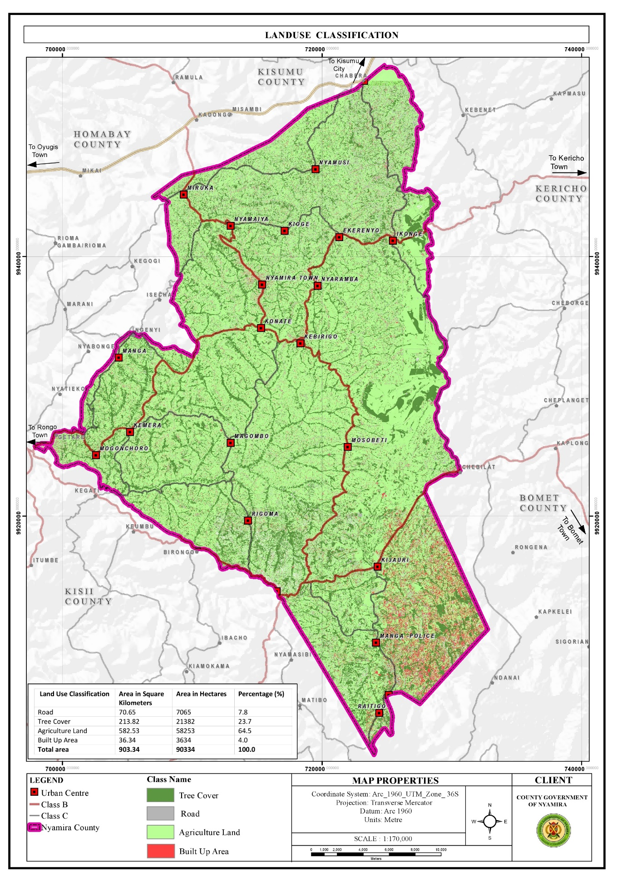

Figure 10

### 3.3.2: Challenges

1. Private land ownership: More than 90% of the county’s land is under freehold and comprises of the rural hinterland. The prevalence of private land ownership makes implementation of county development projects costly due to land acquisition and compensation costs.
2. Unregulated land subdivision: There has been significant land subdivision activities over the years mainly for inheritance purposes as the African culture and traditions dictate that fathers have to subdivide the property, land included to their heirs. Gradually, this practice coupled with population pressure has resulted to uneconomical land holdings
3. Freehold land ownership rights in most parts of the county, freehold land ownership rights are held at extended family where a family title is held in the name of the great grandparents. This poses challenges in succession, land managemet and administration.
4. Land use changes where urban developments are eating up agricultural land Changes in land use patterns are linked to a rapidly increasing population in the rural areas. This growth rate translates to an increased pressure and demand for land resources. The agricultural farms surrounding the towns and market centres are under massive pressure as the land parcels adjacent to the urban centres are gradually being converted to urban land uses. This threatens the sustainability of the agricultural sector in these areas as agricultural land use can’t be high for land as compared to commercial and residential land uses. O
5. Land fragmentation Land fragmentation in the county has been as a result of inheritance practices where all the heirs want to own land parcels both along the road and the riparian reserves. In addition, the small land sizes have forced the well up farmers to purchase or rent additional farm lots away from their original farms to add to their production levels. These fragmented land holdings have negative implications on agricultural production and food security due to the time lost accessing the fragmented parcels. There are also instances of increased disputes with neighbors.

3.4 Environment and Natural Resources:

Nyamira County has several ESAs which include green and open spaces, wetlands, hills/forests and water falls. These ESAs undertake key functions in the sustainability of the environment among them provision, regulatory, economic and cultural functions. They are however threatened by several human activities among them; farming, mining and construction. Opportunities and challenges affecting the environment and natural resources in the county are outlined below:

### 3.4.1 Opportunities:

1. High tree cover: The county has a relatively high tree cover of 35% compared to the recommended national minimum cover of 10%. Trees aid in; air purification through carbon sequestration, soil stabilization and protection from soil erosion, provision of timber and wood fuel and flood mitigation as the roots help in water infiltration to the ground.
2. Availability of several natural resources: The county is endowed with several natural resources like rivers, forest/hills, wetlands and water falls which provide opportunities for conservation, eco-system service provision and promotion of tourism.
3. Conducive climatic conditions for the thriving of these natural resources: The thriving of these natural resources is facilitated by the prevailing conducive climatic conditions in the county.
   * 1. **Challenges**
4. Planting of inappropriate tree species: Majority of the riparian reserves are planted with eucalyptus trees. Eucalyptus trees are widely grown and utilized throughout the world as they are a valuable source of timber and wood fuel. These tree species however deplete groundwater, dominate other tree species and cause loss of soil fertility. They are indeed a key contributing factor to the drying up of some streams and reduction of water levels in some rivers.
5. Deforestation: Despite the high forest cover of 35%, the county suffers from significant deforestation activities. This is mainly as a result of overreliance of wood fuel and the need for other wood products like timber. The county relies mainly on wood fuel for cooking with about 84.3% using firewood and 3.5% using charcoal for cooking. Apart from household wood fuel consumption, the tea factories in the county use firewood to process the tea leaves. In addition, several institutions like schools use firewood for cooking. Furthermore, due to the population pressure in the county, individuals are clearing trees to pave way for settlements and crop farming so as to house and feed the increasing population respectively.
6. Boundary tree planting conflicts: Planting of trees along the farm boundaries is a common practice in the county. Trees are used to demarcate the farm boundaries and in some instances, due to the small land sizes, there are no land parcels left for tree planting and farmers are forced to utilize the farm edges. In addition, competition for land with other farm land use allocations pushes tree planting to the edges as the little available land is allocated to production of staple food. This practice has resulted to significant conflicts as farmers on both sides want to utilize the edges for tree planting.
7. Encroachment of riparian reserves and forests: Rapid human population growth and overexploitation of resources are the main causes of land use and land cover change along river basins. In addition, agricultural land and urban settlements have increased at the expense of forests and grasslands. The conversion of land use and land cover into agricultural land and urban settlements has resulted to various environmental consequences like loss of ecosystem integrity, ecosystem imbalance and below optimum provision of ecosystem services.
8. Poor waste management causing pollution on the rivers: Most of the market centres do not have designated solid waste collection and disposal sites. This has led to sprouting of illegal disposal sites in the market centres as well as indiscriminate waste disposal. The disposal sites are also poorly managed. The poor waste management practices in the county cause significant pollution of the rivers as the waste is swept by surface runoff into the rivers. In addition, about 95% of the households use pit latrines for human waste disposal. The use of pit latrines impacts negatively on the quality of the underground water. The threats are even higher in flood prone areas where these latrines can contaminate surface run off. The health threat of this mode of waste disposal is alarming as about 80% of the population in Nyamira County depend on springs, streams, rivers and wells as the main water sources for their domestic use.
9. Environmental degradation: Environmental degradation in the county is as a result of unsuitable farming methods, effects of climate change, poor solid waste management, soil erosion, deforestation, quarrying activities and invasive species. o Floods and landslides The county is susceptible to flooding and landslides due to the high rainfall amounts experienced in the county coupled with increase in impervious cover.
   1. **Human Settlements and Urbanization**

Human settlements play a critical role in development as they are centres of social interactions, services and utility provision. These settlements are influenced by several parameters among them climatic conditions, infrastructure networks like roads, water and electricity as well as availability and access to gainful employment. Migration of rural population to major towns in search of employment and other services like education and health has resulted to strained infrastructural facilities in these urban centres. The human settlements and urbanization trends in the county present several opportunities and challenges as outlined below:

### 3.4.1 Opportunities

1. Strategic location: The county is located within the LREB among other 13 counties with similar ecological zones, natural resources and analogous cultural histories. The county benefits from the synergist links among the other counties in the bloc. In addition, majority of the towns and market centres are situated along transportation corridors, enhancing their accessibility.
2. Dense settlements provide ready market for products and are cheaper to service Consumption is the main motivation for production, as there won’t be need for production without adequate consumption. The dense populations both in the rural and urban centres translate to demand for goods and services. These dense settlements are also cheaper to service compared to linear and leap frog developments.
3. High percentage of home ownership at 85.5% The county has relatively high percentage of home ownership at 85.5% compared to the national percentage of 61.3%. This could be attributed to the fact that majority of the population resides in the rural areas where they have constructed their homesteads within the agricultural farms.
4. Manga Sub-County is earmarked for the development of housing under the big 4 agenda. Affordable housing is one of the Government’s big 4 agenda with the others being food security, manufacturing and affordable health care. The implementation of the housing project in Manga Sub-County is expected to propel investment in other sectors and spur the area’s economic growth.

**Map 9. Urban Extents**

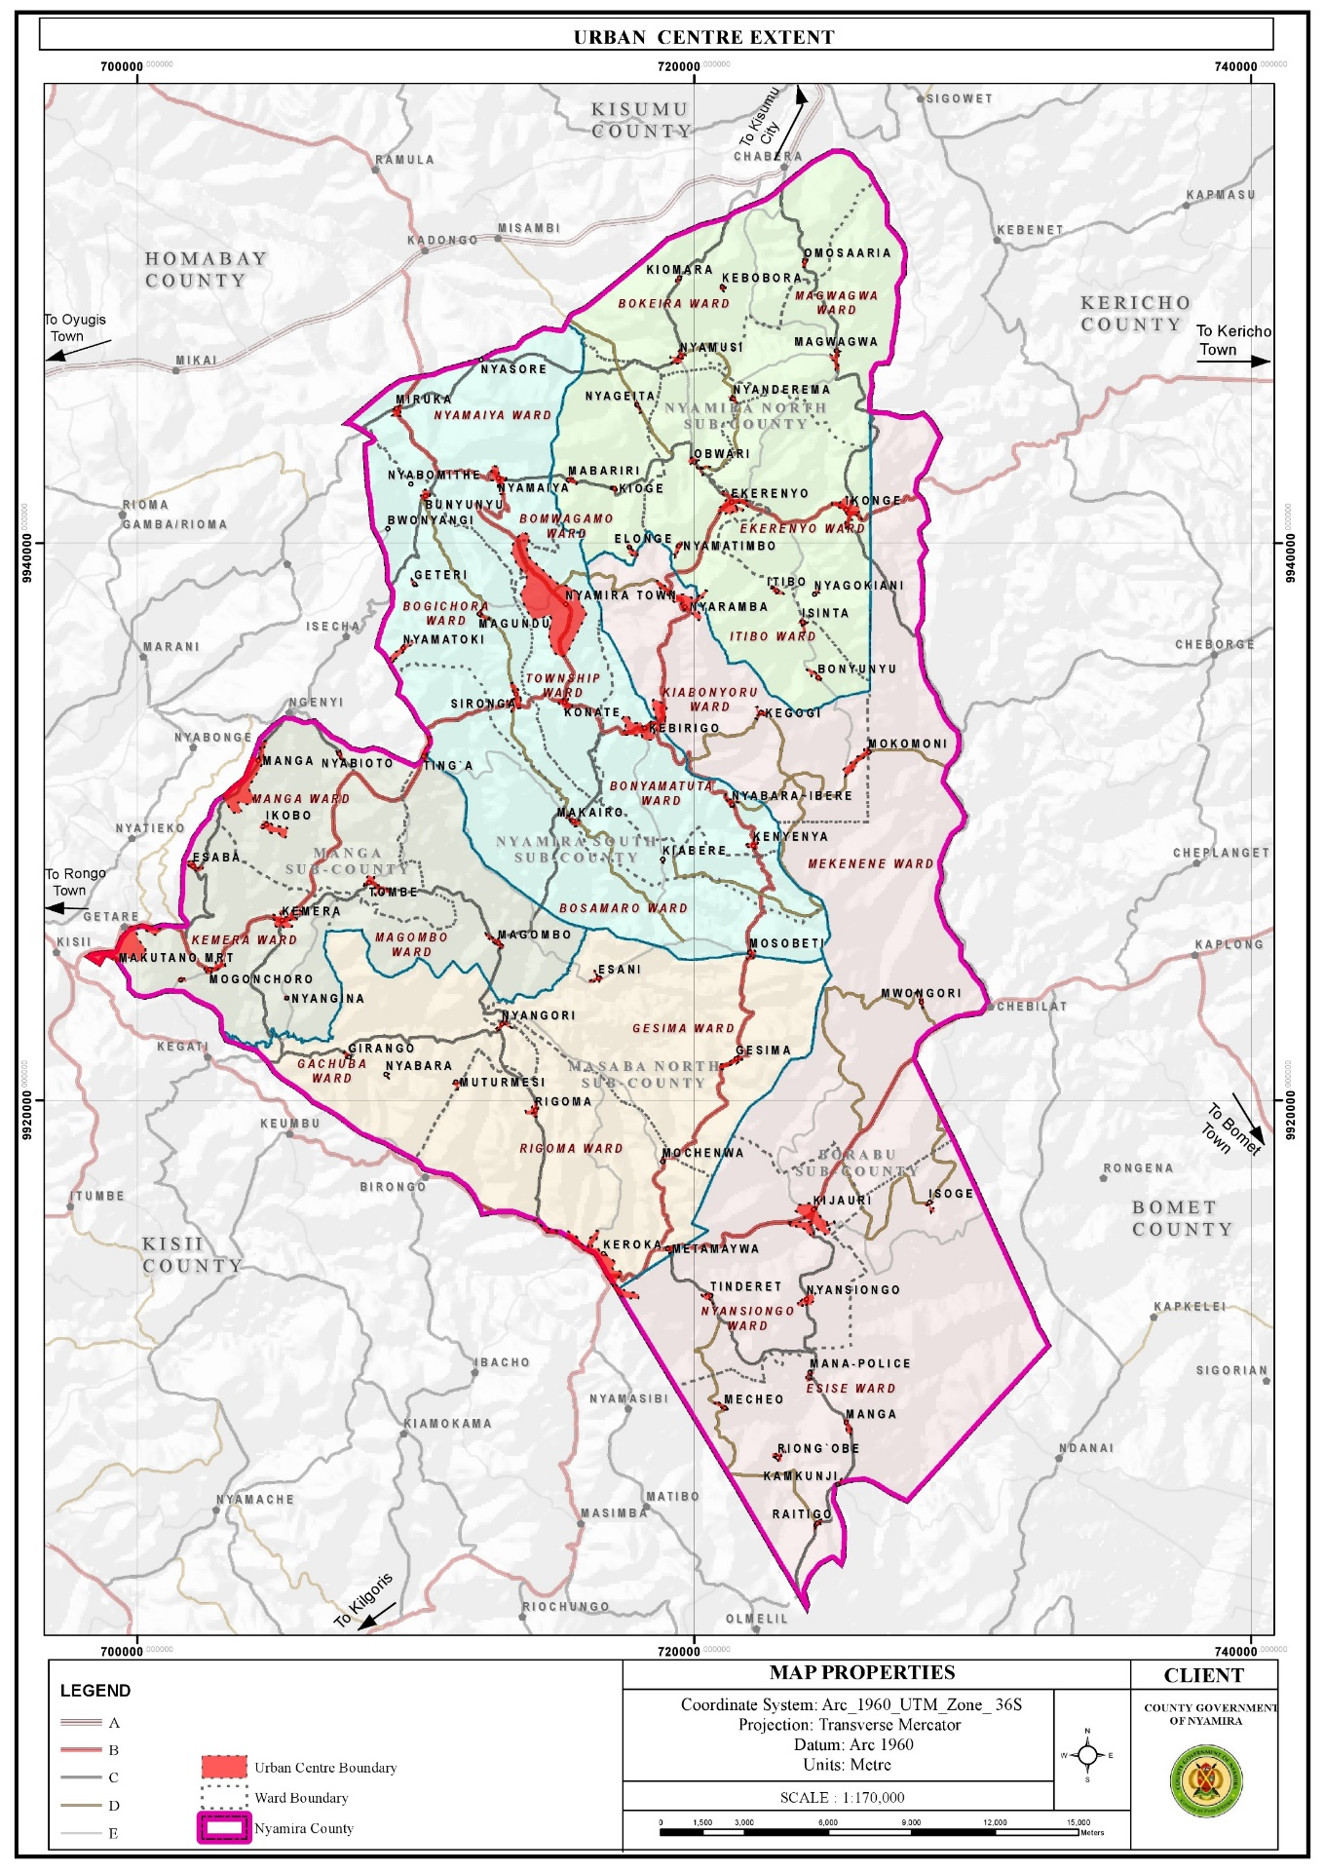

Figure 11

### 3.4.2 Challenges

1. Linear and leapfrog developments: Most market centres have developed along the major roads resulting to linear and leap frog developments. These developments are expensive to service.
2. Haphazard developments, urban decay and poor aesthetics of the market centres The towns and market centres in the county developed without any spatial framework to guide their development. As a result, majority of the centres are characterized by haphazard developments. In addition, the centres are not planned with the exemption of Nyamira Town, Miruka, Nyamaiya, Kioge, Ting’a, Sironga, Nyaramba, Kebirigo and Konate Market Centres though the plans are yet to be implemented. Some of the structures in the towns and market centres are in a dilapidated state as they are characterized by ugly walls and corroded roofs.
3. Poor solid waste management results to poor aesthetics in majority of the urban centres.
4. Limited accessibility and connectivity of the market centres Majority of the roads connecting the market centres are gravel and earth roads. The earth roads are in deplorable condition especially during the rainy season.
5. Inadequate land for future expansion of the urban centres as they are surrounded by freehold farm holdings. Majority of the market centres in the county were established by the former councils who identified public lands for potential growth of these centres and defined their boundaries.
6. Terrain The rugged topography in most of the urban centres has been a major limitation to their growth and development. For instance, construction of roads to certain places especially the hilly and low lands is costly and unfeasible in some areas. This renders some areas inaccessible. In addition, piping of the water from the various water sources in the low lands to the majority of the homesteads in the hilly areas is very costly, rending it unfeasible.

##### **3. 5 Transport, Infrastructure and Services**

Efficient transport, infrastructure services and utilities are prerequisite to socio-economic growth and development. The roads open up resource potential areas, link activity spaces and enable the circulation of goods and services. Water, ICT, energy, sanitation services and social infrastructure function towards uplifting the quality and standards of life for the county residents. This sector is presented with numerous opportunities and challenges as outlined below;

### 3.5.1 Opportunities

1. High connectivity of the county to the regional hinterland via the existing road network in the region: The county is well connected to the hinterland with Kisii-Chemosit road (B4) and Konate-Senta Road (B5) being the main roads connecting the county with other regions. Other roads linking Nyamira County to the rest of the region are; Narok – Kisii (B3), Kisii – Nyamira road (C21), Kisumu – Kisii Road (A1), Oyugis – Kendu Bay Road (C26), Kisii- Rongo Road, Kaplong – Chemasit – Kericho Road, Kericho – Kapsoit – Awasi – Ahero Road, Kebirigo – Ekerenyo – Ikonge – Chemosit Road, Ikonge – Magwagwa – Chabera Road among others

**Map 1: Road Network and Classification**

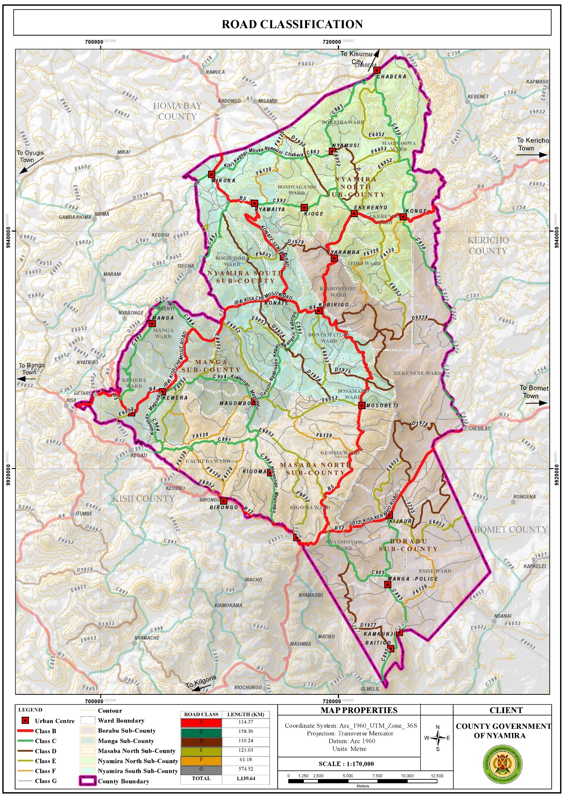

Figure 12

* + 1. **Challenges**

1. Poor road conditions: The county is characterized by poor road conditions with only about 20.1% of the classified roads being of bitumen surface type. About 27.6% of the roads are unclassified and are mainly earth roads. In Bosamaro Ward, for instance all the roads are earth roads. Majority of the gravel roads on the other hand are in poor condition due to poor maintenance and constant erosion of the top surface. The poor road condition especially for the earth roads renders them impassable during the rainy seasons. This poses a challenge in the transportation of farm inputs and produce.
2. Encroachment of road reserves: Majority of the road reserves have been encroached by informal businesses in the urban centres bringing about issues of space contestation between the road users, traders and customers. o Lack of bus terminus and parking spaces Most of the market centres in the county lack bus terminus with the exemption of Nyamira Town, Keroka Town and Ekerenyo Market Centre. This forces the Public Service Vehicles (PSVs) to load and offload along the roads. There are also no parking spaces in the urban centres and motorists are forced to park along the road reserves or building pavements.
3. Poor connectivity between the market centres : Despite the existence of roads connecting all the market centres, some of the roads are in a sorry state. The situation is further aggravated by missing bridges and poor conditions of the available bridges in some of the roads. This makes accessibility to some of the market centres a challenge.

###### **3.6 ICT**

## 3.6.1 Opportunities

1. Relatively high ICT proficient population: About 45% of the county population own mobile phones, 16% utilize the internet while 7% use laptops, tablets, computers and desktops. This presents opportunities for engagement in ICT related businesses.
2. Easier accessibility of ICT equipments : Accessibility to ICT equipment has become easier over the years since their introduction in the country. There are several electronic shops in the county headquarters (Township) where the county residents can access various devices at their convenience.

**3.6.2 Challenges**

1. Low budgetary allocation and inadequate staffing to operate the ICT infrastructure. o Inadequate skills in the ICT sector among staff in the county departments coupled by lack of training programmes to equip the staff with the required skills.
2. Low network reception in some areas, especially the low land areas as reception is hindered by the hilly areas. The residents have to move to higher grounds in search of network reception o Lack of resource centres, GIS lab and equipment for data storage and retrieving

**3.7 Energy**

## 3.7.1 Opportunities

1. Renewable energy sources: The Northern parts of the county comprising of the areas around Miruka, Nyamusi and Chabera have high solar potential that can be harnessed for solar power generation even at the household level. The area around Manga ridges, an area near Birongo Market Centre in Masaba North SubCounty and an area near Ekerenyo Market in Nyamira South Sub-County with relatively high wind power density of between 301 - 400 Watts per Square Metre are potential areas for wind power generation. There is also potential for production of biomass for cooking, though at household level. Tapping into these renewable energy sources could help minimize the negative effects of climate change.
2. Last mile connectivity : This presents an opportunity to connect other areas with electricity. 11.7.3.2 Challenges o Over-reliance on wood fuel for cooking Wood fuel is the main source of cooking energy with 84.3% and 3.5% of the population using firewood and charcoal respectively. In addition, the tea factories in the county use firewood for the processing of tea leaves. The use of wood fuel has implications on the environment as it leads to air pollution and reduction in tree cover.
3. Low electricity reticulation as some of the areas are not connected to the national grid : The current electricity coverage in the county stands at 49.5% which translates to about 85,548 connections. There are areas without electricity connectivity in the county like; Obwari, Gesura, Ensoko and Kiabora. These areas need to be connected to the national grid as electricity is a major component of socio-economic development.

**Map 11: Electricity Reticulation Map**

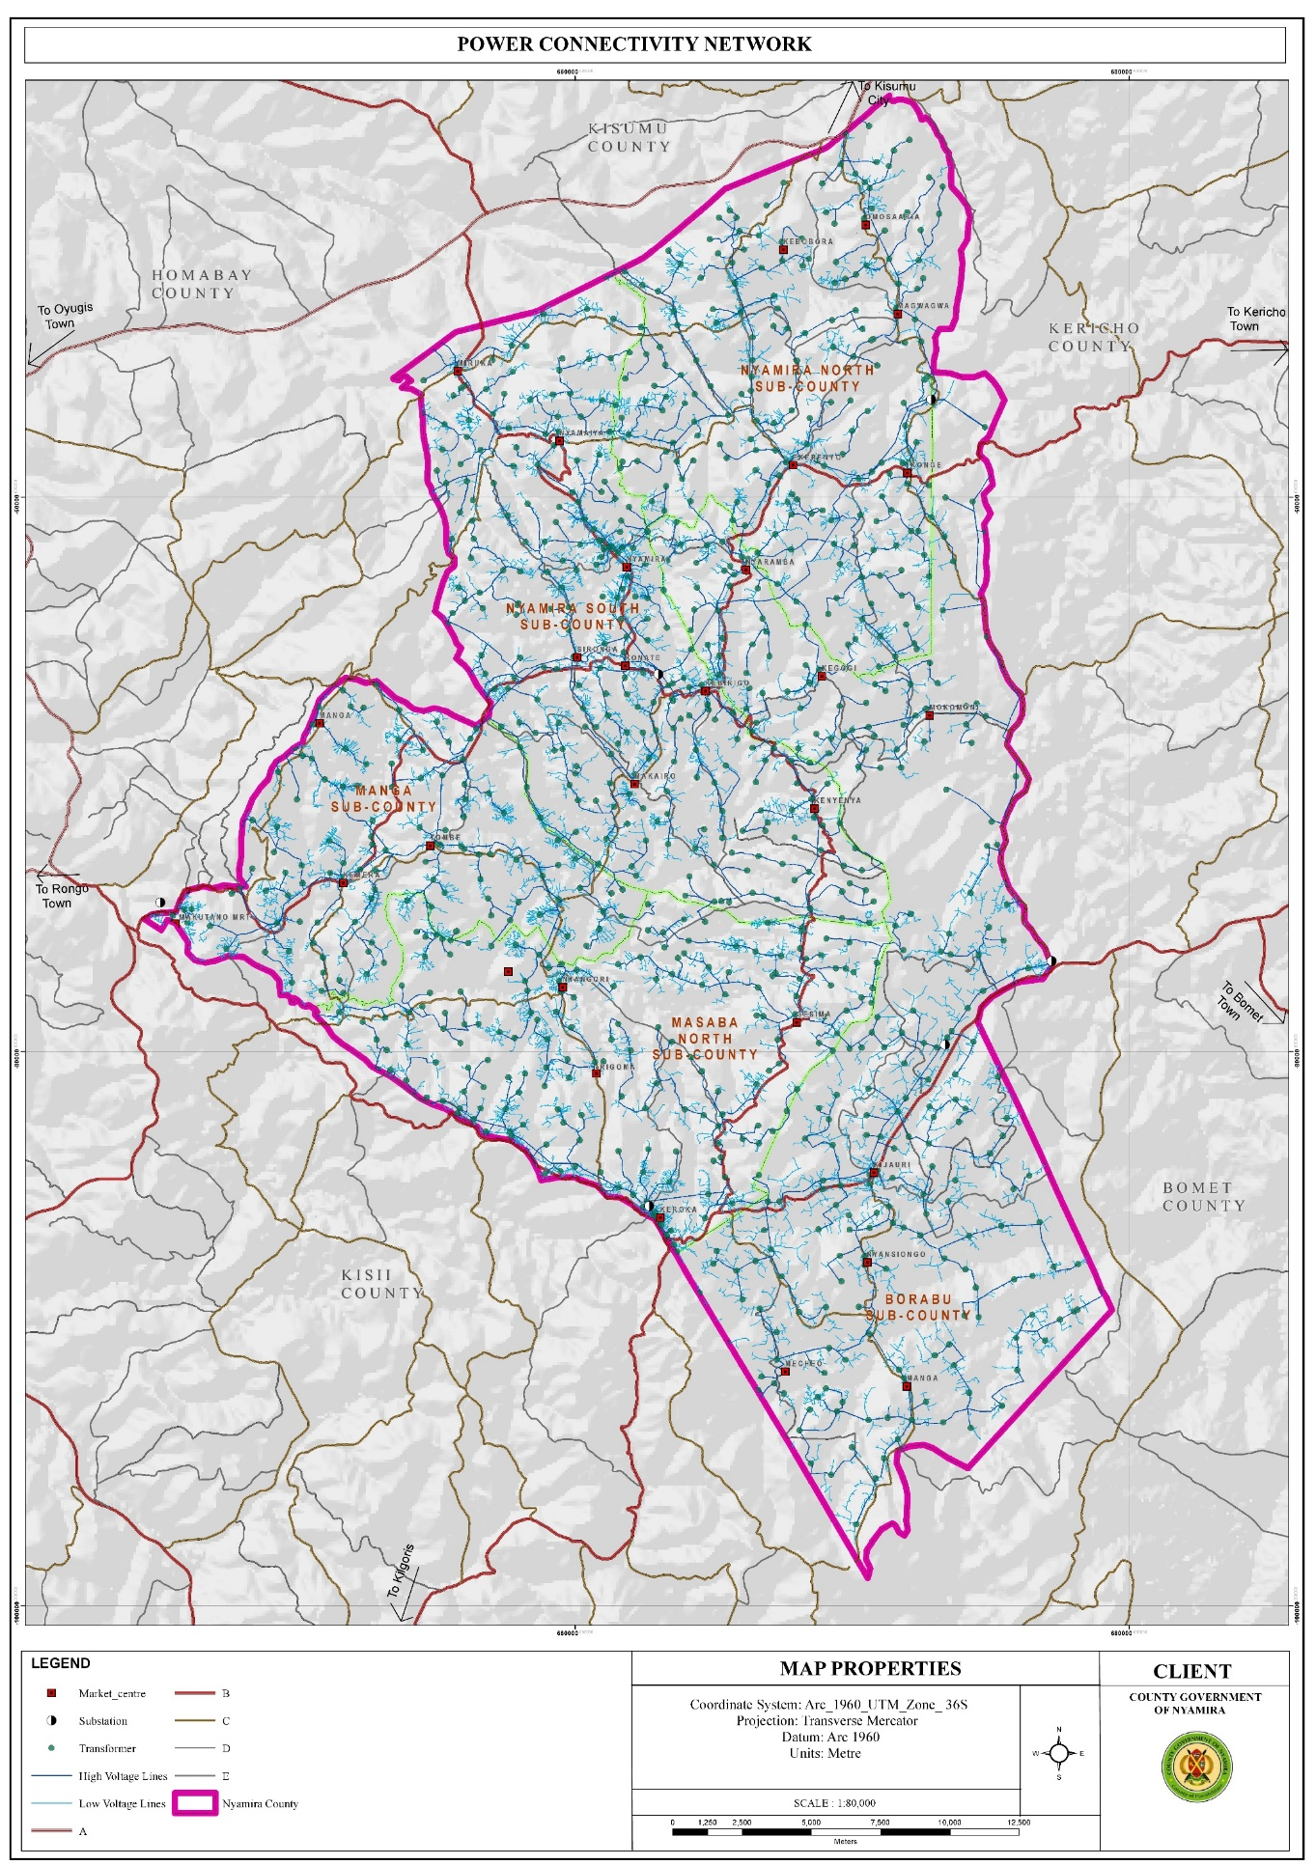

Figure 13

**3.8 Water and Sanitation**

## 3.8.1 Opportunities

1. Availability of water sources both surface and underground water sources : The county has about 2,021 shallow wells, 735 protected springs, 69 dams as well as over 2,790 unprotected springs and 7 permanent rivers. The availability of these water sources presents opportunities for easier access to water for both domestic and agricultural use.
2. High rainfall amounts present an opportunity for rain water harvesting The high rainfall patterns of between 1200 mm – 2100 mm per annum present an opportunity for rain water harvesting through creation of large-scale runoff collection reservoirs and household rainwater harvesting.
3. High water tables: The high-water tables in the county present opportunities for drilling of shallow wells. This explains the high number of shallow wells at the county which stands at 2,021. o Availability of waste The current solid waste generation in the county as at 2021 amounts to 104,146 tonnes and is projected to be 116,024 tonnes in 2030.

**Map 12: Water Sources**

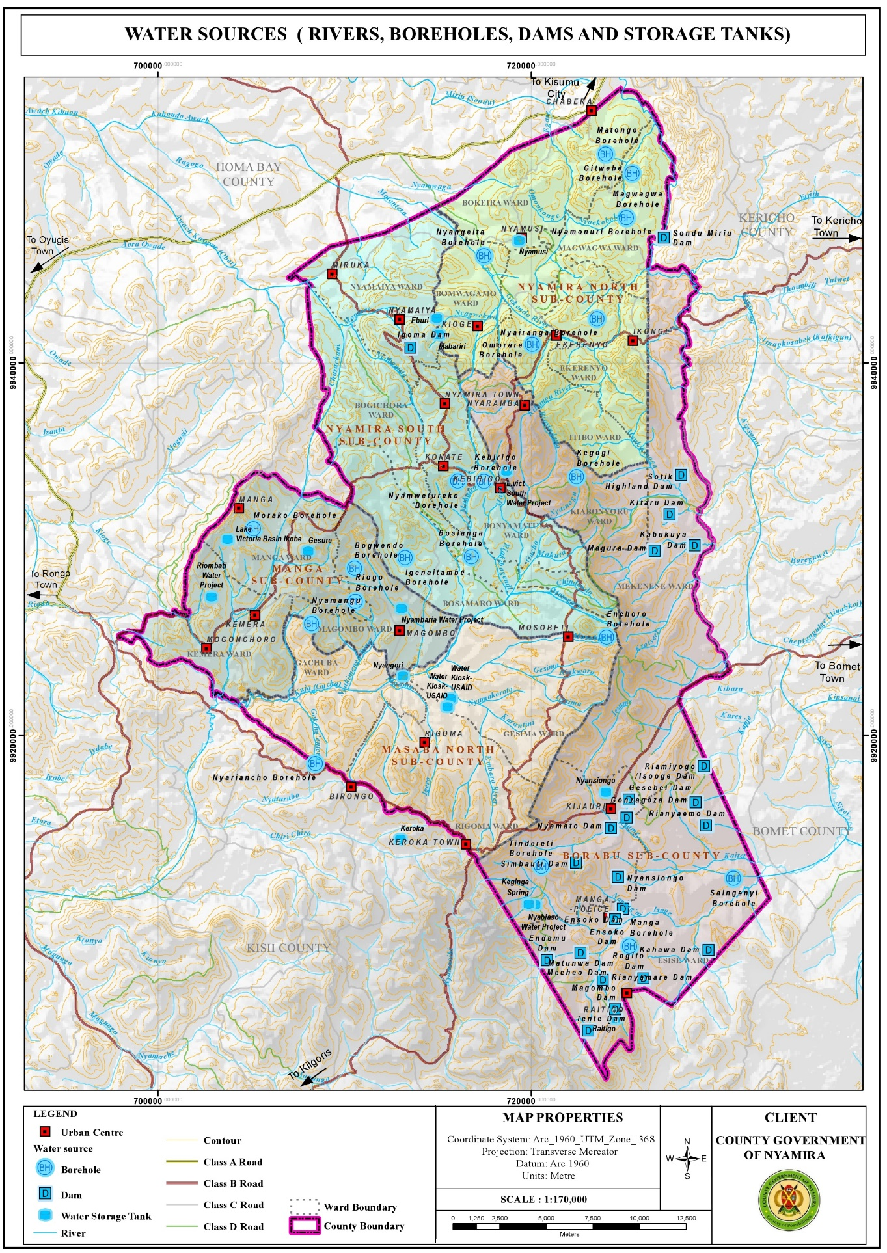

Figure 14

## 3.8.2 Challenges

1. Water: Over reliance on river and spring water Springs and rivers are the main water sources in the county, with about 36.6% using water from the streams/rivers while 36.4% and 9.4% utilize water from protected and unprotected springs respectively. o Inadequate water for the market facilities Water reticulation is only available in Nyamira and Keroka Towns. The rest of the towns rely on obtaining water from their natural sources.
2. Inaccessibility of water sources Despite the numerous water sources available in the county, water is not accessible to majority of the residents residing on the hilly areas as majority of the water sources are located at the low lands. The situation is further aggravated by the area’s topography which makes development of water reticulation from the low areas to the hilly areas unfeasible.
3. Poor water quality: The water quality in the county is compromised by constant pollution from the poor waste management practices carried out. Lack of designated solid waste management sites in most of the market centres has resulted to indiscriminate disposal of waste
4. Unprotected dams The unprotected dams are safety hazards to the county population as they are potential drowning areas. Siltation of some of the dams has made them dysfunctional over the years while privatization of others has made them inaccessible to the general public.
5. Rivers/springs : The rivers and springs are threatened by the planting of inappropriate tree species mainly eucalyptus trees. These tree species are a key contributing factor to the drying up of some streams and reduction of water levels in some rivers, wetlands and springs. o Lack of sewer reticulation network in the major urban centres Sewer reticulation is only available in Keroka Town. The rest of the urban centres don’t have a sewer reticulation network.

**3.9 Education**

* + 1. **Opportunities**

1. Have adequate schools : Based on the standards for the provision of educational facilities as outlined in the Physical Planning Handbook (2007), the existing educational facilities in the county are in surplus. This offers adequate learning institutions for the school going population. Presence of tertiary institutions The county has a total of 54 public TVETs spread across the county. The presence of tertiary facilities presents opportunities to further education as it offers alternatives to transition from secondary education to skill development. The student and staff population in these institutions provides a ready market for farm produce grown in the county and present opportunity for the construction of accommodation facilities.
   * 1. **Challenges**
2. Location of schools in the wetlands especially in Sironga making it difficult for infrastructure development
3. High number of pupils/students in boarding schools resulting to overstretched infrastructural facilities and services
4. Derelict infrastructural facilities in most of the public primary schools. o Poor waste management; solid waste is burnt in the open while inadequate land sizes constrain construction of additional pit latrines.
5. Poor accessibility of some of the schools within the rural areas due to impassable roads during the rainy season
6. Inadequate support infrastructure like appropriate sanitation facilities and learning materials o Delay in disbursement of funds to public schools affecting the smooth operation of school programs
7. High pupil/student teacher ratios in the public schools leading to overstretched teaching staff and poor performance of the pupils in national exams.
8. Inadequate land for the tertiary institutions as most of them are housed within primary or secondary schools land.
9. Inadequate schools for the physically challenged pupils forcing them to attend the normal schools without the prerequisite facilities for their learning.
10. Lack of water in some institutions making pupils carry water with jerricans to school. This practice is quite tiring to some of the pupils, thus affecting their concentration in class and their performance in general.

**Map 12: Distribution of Primary Schools**

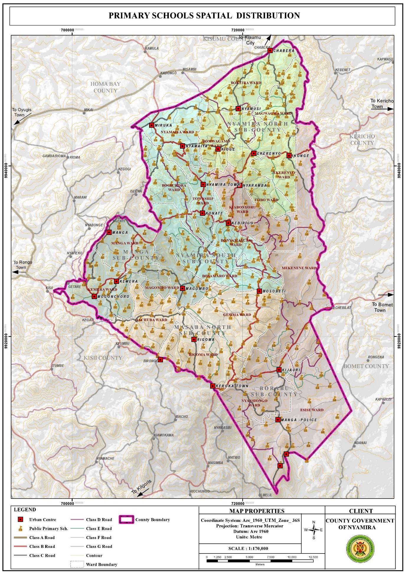

**Map 13: Distribution of Secondary Schools**

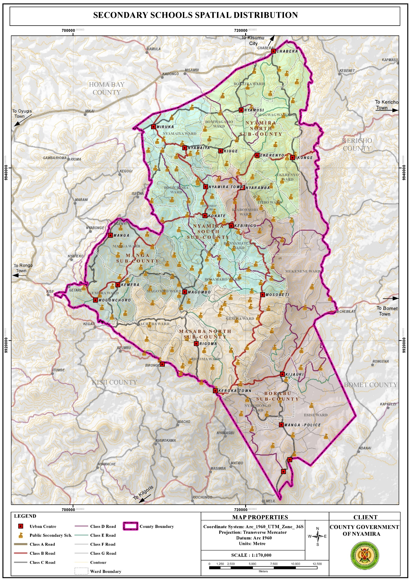

Figure 15

**Map 14: Distribution of Tertiary Institutions**



# **3.10 Health**

## 3.10.1 Opportunities

1. Availability of county referral hospital Nyamira County Referral Hospital is a government health facility which provides comprehensive medical and surgical services. The presence of the facility within the county presents a good opportunity to the county residents to access high level medical services in close proximity.
2. Adequate health facilities Based on the standards given by the ministry of health with regard to provision of health facilities versus the catchment population, the county has adequate public health facilities. However, despite the over-provision of health facilities, private health facilities have been mushrooming. This could be attributed to the deplorable state of some of the public facilities and lack of the requisite equipments and drugs.

## 3.10.2 Challenges

1. Inadequate staffing leading to overstretched medical staff. The doctor: population ratio is 1:11,906 against the Kenyan ratio of 1 doctor per 10,000 people. This indicates overstretched medical personnel. The inadequacy in staffing leads to low motivation hence low productivity. o Poor accessibility of some health facilities located in the rural areas due to impassable roads during the rainy season.
2. Inadequate medical equipment, drugs and lack of specialized treatment in most public facilities leading to sprouting of private facilities.
3. Poor conditions of some of the health facilities, for instance some of the facilities are in derelict state rendering then dysfunctional.
4. Stalled projects; the construction of most of the proposed health facilities has stalled.
5. Mushrooming of private health facilities to fill in the niche as a result of poor services in the public health facilities.
6. Increased lifestyle diseases among the elderly for example high blood pressure, diabetes and arthritis hence the need for special facilities to help fight such illness.
7. Locational disadvantage of some of the health facilities like Ikonge dispensary which is located downhill making it inaccessible to majority of the residents due to the county’s rugged terrain.

**Map 15: Distribution of Health Facilities**

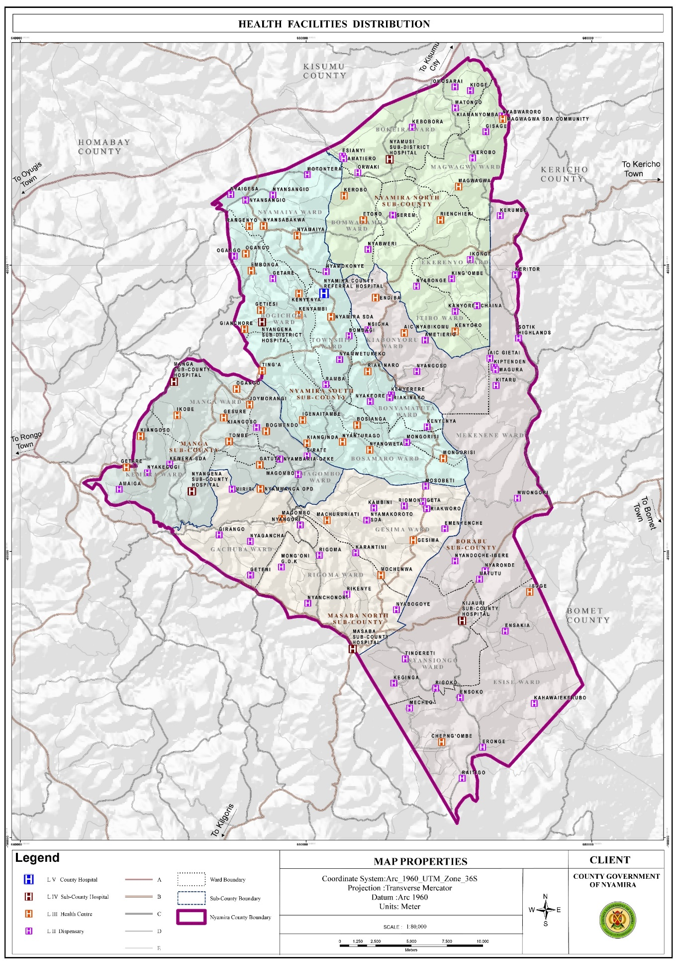Figure 16

# 

# **CHAPTER 4**

# **DEVELOPMENT PRIORITIES, STRATEGIES AND PROGRAMMES**

## 4.1.1 Sector Name:

**GENERAL ECONOMIC, COMMERCIAL AND LABOR AFFAIRS.**

* **Sector composition**:

The Sector A nationally and globally competitive county economy with sustainable and equitable socio-economic development through promotion of trade, investment and enterprise development

* comprises Trade, Weights and Measures, Industrialization, Tourism and Micro and Small Enterprises
* This sector is mainly responsible for the promotion and development of commercial and economic activities including value addition and consumer protection

* **Vision and Mission:**
* **Vision**

A nationally and globally competitive county economy with sustainable and equitable socio-economic development through promotion of trade, investment and enterprise development

**Mission**

To promote, co-ordinate and implement integrated socio-economic policies and programmes for a rapidly industrializing, investing and entrepreneuring economy

**Sector Goal(s)**:

* The overall goal of the Department is economic empowerment through creation of conducive business environment, mobilization of Savings and investments.

## Sector Priorities and Strategies:

* Empower the county citizens economically
* Tap tourism opportunities in the county
* Industrialize the county to maximize utilization of availability raw materials through value addition
* To promote enterprise development and inculcate entrepreneurial culture within the county
* Ensure fair trade practices and consumer protection.
* Ensure better service delivery
* Contribute to County Revenue generation
* Ensure orderly growth in trade through business Regulation

Table 5: Sector Priorities and Strategies

|  |  |
| --- | --- |
| 1. **Sector Priorities(trade development*)*** | **Strategies** |
| 1. Provide safe and hygiene trading environment 2. Better managed markets 3. Carry out business training 4. A reliable traders data bank 5. Provide traders with loans/funds 6. Equip clients with information and network | * Secure trading space by fencing markets, * Construct markets and market Sheds, * Open new markets, * Construct market Toilets to allow a hygiene environment, * Construction of warehouses, * Install lighting in markets, * Supply water to markets, * Open and improve access roads to markets, * Additional market days, * Market repairs, * Control of storm waters in markets, * Develop market management policies and other legislations. * Constitute market committees. * Conduct market committee elections * Conduct business trainings to improve business skills, * Enhance sensitisation on business matters and opportunities, * Organize Investment forums, * Promote saving culture * Conduct business mapping to ensure there is reliable data on businesses, * Licence all businesses, * Collect revenue from all businesses through Single Business Permits, * Review revenue rates i.e. SBP,market fee to make them affordable, * Enhance market due collections * Develop legislation to provide loan kitty, * Give affordable loans to deserving businesses * Identify participants for various exhibitions * Explore relevant exhibition for participation by officers and traders, * Participate in identifying products to be exhibited, |

|  |  |
| --- | --- |
| **Sector Priorities(industrialization*)*** | **Strategies** |
| 1. To attract local and foreign industrial investment 2. Promote value addition in the counties 3. Generate employment opportunities 4. Improve product competitiveness and business environment | * -Conduct training needs analysis from which we derive areas of training e.g. marketing, value addition, record keeping * -Mobilize the relevant supporting institutions like KIE, KEBS, KIRDI, KIPI etc. to disseminate information on their products and services on the ground. * Hold exhibitions modelled under One Sub County One Product * Provide specific tools and machines to entrepreneurs and innovators based on strengths from a particular area cluster. * -Build worksites and industrial development centres in each Sub County |

|  |  |
| --- | --- |
| **Sector Priorities(weights and measures*)*** | **Strategies** |
| 1. Create and ensure a level playing field that facilitates fair competition in trade transaction involving quantity measurement. 2. Ensure use legal weighing and measuring equipment’s 3. Increased inspection activities | * Train traders on fair trading practices, * Sensitize consumers their rights, * Enforce the existing laws and regulations by conducting regular inspection of traders premises * Carry out verification of traders weighing instruments |
| Ensure maintainance of uniformity of all weighment and measurements in trade through procurement and maintenance of physical standards of weights and measures. | * Examine, test and stamp weighing and measuring equipment in use for trade * Certify weighing and measuring equipment * Carry out inspection on persons selling and repairing weighing and measuring equipment. * Carry out bi-annual calibration of standard in compliance with primary national standard |
| Continuously ensure all weighing and measuring equipment for trade use are accurate, | * Examine, verify, stamp and certify the weighing and measuring equipment the trader is using, * Examine, verify, stamp and certify the weighing and measuring equipment the trader is using, * Carry out the investigation of complain pertaining fraudulent use of weighing and measuring equipment. * Prosecute the trader infringing laws and regulations governing trade. |
| Improve revenue collection | * Certify all weighing and measuring equipment in use for trade * Regular inspections of weighing and measuring equipment in use for trade. * Procure weights and measures working standards and tools. |

|  |  |
| --- | --- |
| **Sector Priorities(tourism*)*** | **Strategies** |
| To promote  tourism  development | Marketing and  branding of  tourist attraction  sites  Diversification  of tourism products;  Development, maintenance  and adequate  financing of tourist  attraction sites  Provide adequate  facilities at the tourist  attractions site  Harnessing Agri  Tourism, Eco  Tourism and Conference  Facilities  Surveying and demarcate the sites to avoid encroachment |

## 

## 4.2 Sector Programmes and Flagship Projects

## 4.2.1 Sector Programmes

Table 6: Sector Programmes

|  |  |  |  |  |  |  |  |  |
| --- | --- | --- | --- | --- | --- | --- | --- | --- |
| **Programme Name:**  Trade Promotion and Investment Development | | | | | | | | |
| **Objective:**  Create a conducive business environment | | | | | | | | |
|
| **Programme Name: Trade Promotion and Investment Development** | **Key Output** | **Key Performance Indicators** | **YEAR 5** | | **YEAR 5** | | **TOTAL** | |
|  | **TARGET** | **COST** | **TARGET** | **COST** | **TARGET** | **COST** |
| *\* 1.Market infrastructure development and Management | Modern Market constructed | Number of modern markets | 10 | 90 | 10 | 90 | 20 | 180 |
|  | Markets Sheds constructed | Number of market sheds constructed | 10 | 32.5 | 10 | 32.5 | 20 | 65 |
|  | Markets fenced | Number of markets fenced | 10 | 16 | 10 | 16 | 20 | 32 |
|  | Mama Mboga sheds established | Number of mama mboga sheds constructed | 10 | 11.4 | 10 | 11.4 | 20 | 22.8 |
|  | Markets repaired | Number of markets repaired | 18 | 9.8 | 18 | 9.8 | 36 | 19.6 |
|  | Modern Ablution blocks constructed in major market centres | Number of modern Ablution blocks constructed in major market centres | 7 | 57.3 | 7 | 57.3 | 14 | 114.6 |
|  |  | Investors conferences | 1 | 100M | 1 | 110M | 2 | 210M |
|  | Modern toilet constructed | Number of Modern toilets constructed | 15 | 48 | 15 | 48 | 30 | 96 |
|  | Modern stalls/kiosks constructed | Number of Modern stalls/kiosks constructed | 25 | 68.2M | 25 | 68.2M | 50 | 136.4M |
|  | Construct Shoe Shine Sheds in market centres | Number of Shoe Shine sheds Constructed in market Centre | 9 | 5.5M | 9 | 5.5M | 18 | 11M |
|  | Supply markets with water including drilling boreholes | Number of markets supplied with water including drilling boreholes | 5 | 16.8M | 5 | 16.8M | 10 | 33.6M |
|  | Market committees Established | Number of Market committees Established | 13 | 1.7 | 13 | 1.7 | 26 | 3.4 |
|  | Market committees election held and facilitate | Number of Market committees election held and facilitate | 38 | 4.4M | 38 | 4.4M | 76 | 8.8M |
| 2.Traders Capacity building and awareness creation | 1.Traders trainings conducted on business management and awareness creation | Number of traders trainings on business skills held | 20 | 8.5M | 20 | 8.5M | 40 | 17M |
|  | Business sensitization for information dissemination and awareness creation conducted | Number of sensitizations on business related matters held | 38 | 4.2M | 38 | 4.2M | 76 | 8.4M |
| 3.Market access through Participation in trade fairs and exhibitions | International and Regional trade fairs and exhibitions participated | Number of International and Regional trade fairs and exhibitions participated | 20 | 25M | 20 | 25M | 40 | 50M |
|  | Local trade fairs and exhibitions participated | Number of Local trade fairs and exhibitions participated | 20 | 7M | 20 | 7M | 40 | 14M |
| 4.Business Regulation and Revenue generation | Business mapping to have data of all businesses carried out | Number businesses mapping to develop data on all businesses | 5 | 5.8M | 5 | 5.8M | 10 | 11.6M |
|  | Sensitizations and meetings of licensing team to plan and strategize on licensing and revenue generation | Number of meetings to plan and strategize on business licensing and revenue collection improvement done | 10 | 2.9M | 10 | 2.9M | 20 | 5.8M |
|  | Business Licenses issued | Number of businesses licensed | 16000 | 8.6M | 16000 | 8.6M | 32000 | 17.2M |
|  | Market fee /dues collected | Amount of Revenue generated from market fee | 45 | 6.4M | 45 | 6.4M | 90 | 12.8M |
| 5.Affordable Business finance | Traders Revolving loan Scheme established through enactment of an Act | Number of loan scheme established by enacting an Act | 5 | 16.3M | 5 | 16.3M | 10 | 32.6M |
|  | Businesses funded | Number of businesses funded | 850 | 7.5M | 850 | 7.5M | 1700 | 15M |
|  | Amount lent to businesses | 250 | 6M | 250 | 6M | 500 | 12M |
|  | Loan repayment from beneficiaries | Amount of loan paids | 87.5 | 43.9M | 87.5 | 43.9M | 175 | 87.8M |

|  |  |  |  |  |  |  |  |  |
| --- | --- | --- | --- | --- | --- | --- | --- | --- |
| **Programme Name: Tourism promotion and development** | | | | | | | | |
| **Objective:** To promote and market tourism in the county. | | | | | | | | |
| **Outcome:** Increased Tourism Sector Contribution to the County’s Earnings | | | | | | | | |
| **Sub Programm** | **Key Output** | **Key Performance Indicators** | YEAR 5 | | YEAR 5 | | TOTAL | |
|  |  |  | **TARGET** | **COST** | **TARGET** | **COST** | **TARGET** | **COST** |
|  | County branding | No of branding done | 30 | 30M | 30 | 30M | 60 | 60M |
| Tourism exchange forum | No of forums held | 10 | 90M | 10 | 90M | 20 | 180M |
| Tourism fairs/exhibitions hosted | No. of fairs held | 5 | 10M | 5 | 10M | 10 | 20M |
| Tourism Infrastructure Development | Tourist attraction sites protected and developed | No of tourist attraction sites protected | 7 | 35M | 7 | 35M | 14 | 70M |

|  |  |  |  |  |  |  |  |  |
| --- | --- | --- | --- | --- | --- | --- | --- | --- |
| **Objective: To ensure the use of accurate weighing and measuring equipment’s in trade transactions encourage fair trade practices and protect consumers in order to enhance social economic development.** | | | | | | | | |
| **Outcome:** Increased consumer satisfaction and compliance to laws and regulation | | | | | | | | |
| **Sub** | **Key Output** | **Key** | YEAR 5 | | YEAR 5 | | TOTAL | |
| **Programme** | **Performance Indicators** | TARGET | COST | TARGET | COST | TARGET | COST |
| 1.      Promotion of fair-trade practices and consumer protection | Weighing and measuring equipments verified | Number of weighing and measuring equipments verified | 13600 | 6.5M | 13600 | 6.5M | 27200 | 13M |
| Revenue collected | Amount of revenue collected | 4350000 | 0 | 4350000 | 0 | 8700000 | 0 |
| Traders premises inspected | Number of trader’s premises inspected | 1000 | 12.5M | 1000 | 12.5M | 2000 | 25M |
| Complaint registered and investigated | Number of complaint registered and investigated | 62 | 3.7M | 62 | 3.7M | 124 | 7.4M |
| Weights and measures Cases prosecuted in the court of law | Number of weights and measures cases prosecuted in the court of law | 15 | 5M | 15 | 5M | 30 | 10M |
| Traders/consumers trainings conducted | Number of trainings conducted | 20 | 12M | 20 | 12M | 40 | 24M |
| Calibration of working standards at national legal metrology laboratory | Bi- annual calibration of working standards | 10 | 3M | 10 | 3M | 20 | 6M |
| Establish weights and measures workshop and Procure working standards | Workshop established | Number of workshop established | 5 | 7.5M | 5 | 7.5M | 10 | 15M |
| Working standards procured | Number of standards procured | 9 | 15.5M | 9 | 15.5M | 18 | 31M |

|  |  |  |  |  |  |  |  |  |
| --- | --- | --- | --- | --- | --- | --- | --- | --- |
| **PROGRAMME NAME:** INDUSTRIAL PROMOTION AND DEVELOPMENT | | | | | | | | |
| **OBJECTIVE:** BUILD RESILIENT INDUSTRIAL INFRASTRUCTURE, PROMOTE SUSTAINABLE INDUSTRIALIZATION AND FOSTER INNOVATION | | | | | | | | |
| **OUTCOME:** IMPROVED INDUSTRIAL ENVIRONMENT | | | | | | | | |
| **Sub Programme** | **Key Output** | **Key Performance Indicators** | YEAR 5 |  | YEAR 5 |  | TOTAL |  |
|  |  |  | **TARGET** | **COST** | **TARGET** | **COST** | **TARGET** | **COST** |
| 1.Industrial infrastructure development | Industrial development centres and food processing plants | No. of industrial centers and food processing plants established | 25 | 81 | 25 | 81 | 50 | 162 |
| Renovation and refurbishment ofindustrial development centres and food processing plants | No. of Industrial development centres refurbished | 14 | 22 | 14 | 22 | 28 | 44 |
| Establishment of a leather processing plant | No. of plants established | 5 | 250 | 5 | 250 | 10 | 500 |
| Equiping the centres with tools and machines | No. of tools and machines provided | 15 | 39 | 15 | 39 | 30 | 78 |
|  | Local, regional and international shows and exhibitions | No. of shows and exhibitions conducted | 25 | 42 | 25 | 42 | 50 | 84 |
|  |  | No. of trainings conducted |  |  |  |  |  |  |
|  |  |  | 40 | 15 | 40 | 15 | 30 | 80 |

## 4.2.2 Flagship Projects

Table 7: Flagship Projects

|  |  |  |  |  |  |  |  |  |
| --- | --- | --- | --- | --- | --- | --- | --- | --- |
| **Project**  **Name** | **Location** | **Objective** | **Description of Key Activities** | **Key**  **Output(s)** | **Time Frame\*** | **Estimated cost (KSh.)** | **Source of Funds** | **Lead Agency** |
| Nyamira Integrated Agro Industrial Park ( IAIP) | Sironga | Enabling inclusive rural economy structural transformation through agro industrialization | -Land demarcation  -Fencing  -Prefeasibility  -Feasibility  -Business plan preparation  -construction  -operation and adaptation | -Prefeasibility and feasibility reports  -perimeter fencing  -stakeholders meetings | Mulit-year project | 18B | -National government -County government  -Development partners | UNIDO |
| Revolving fund | County wide | Sensitize and promote traders | -Feasibility  -Business plan preparation  -construction  -operation and adaptation | -stakeholders meetings  Prefeasibility and feasibility reports | 5 years | 50M | -County government | -County government |

## 4.3 CIDP Linkages with National Development Agenda, Regional and International

## 4.4 Cross-Sectorial Linkages

Table 8: Cross-sectoral impacts

|  |  |  |  |  |
| --- | --- | --- | --- | --- |
| **Programme Name** | **Linked**  **Sector(s)** | **Cross-sector Impact** | | **Measures to Harness or Mitigate the Impact** |
| **Synergies*/benefits** | **Adverse impact** |
| Road’s infrastructure | Trade | Connection to market centres | Pulling down of structures on road reserve | Establishment of market centres and parking bays along the roads; Develop a resettlement plan. |
|  | Environment | Condusive environment for businesses | Environment pollution | Comply and enforce NEMA guidelines |
| Trade | Road’s infrastructure | Connect to market centres | Pulling down of structures on road reserve | Identify public lands and have them gazette |
| Lands and physical planning | More land for trade centres to be constructed | encroachment of public lands | Land identification and demarcation |
| Agriculture rural and urban development | Increase in more revenue accumulation | Environment pollution | Comply and enforce NEMA guidelines |
| Tourism | Gender, Sports and Cultural promotion | Tapping and nurturing of local talents | Talent academies not established | Engaging other stakeholders to boost sports activities |
| Weights and measures | Agriculture, Rural and Urban development |  |  |  |
| Roads, energy and ICT |  |  |  |
| Industrialization | Agriculture, Rural and Urban development |  |  |  |

## 

## CHAPTER FIVE

## IMPLEMENTATION FRAMEWORK

## 5.1. Overview

This chapter should provide the county’s institutional arrangement and their specific roles towards implementation of the CIDP. In addition, the chapter should present the resource mobilization and management framework, asset management, and risk and mitigation measures.

## 5.2. Institutional Framework

*Figure 3: Organizational Chart*

**2.2.2 Roles of the Structures**

Field Extension Services

Division of Audit Services

Industrialisation

Enterprise Development

Weights and Measures

Tourism

Cooperatives

Trade and Investment

CHIEF OFFICER’S OFFICE

EXECUTIVE COMMITTEE MEMBER OFFICE

Table 9: Institutional Arrangement

|  |  |  |
| --- | --- | --- |
| **S/No**. | **Institution** | **Role in Implementation of the CIDP** |
| 1. | County Executive Committee | * Head of the Department who coordinates policy formulation and implementation as well as overseeing the implementation. Represent the Department in the executive committee, approves appointment of sub-committees to assist policy implementation. In addition, the officer is in charge of Resource mobilization at county and outside the county levels. |
| 2. | CCO(COUNTY CHIEF OFFICER) | the officer is in charge of administration and accounting for financial undertakings of the Department. Also the CO oversees the implementation of the strategic plan and also links the department to the ECM |
| 3. | Division of trade | promotion of trade and investment as well as coming up with a development policy |
| 4. | Division of cooperatives | financial, supervisory and advisory services to cooperative societies |
| 5. | Division of tourism | promotion and diversification of tourism activities through infrastructural development and marketing |
| 6. | Division of weights and measures | ensuring fair trading practices and consumer protection in the market through regular monitoring, inspection and availing of consumer information |
| 7. | Division of enterprise development | development of micro and small business enterprises through loaning, infrastructural development and capacity building activities |
| 8. | Division of industrialization | Facilitate industrial development and transformation in the county as well as promotion of retail and wholesale markets |

## 5.3 Resource Mobilization and Management Framework

This section should provide the projected resource requirements by sector, revenue projections, estimated resource gap and measures of addressing the gaps.

### 5.3.1 Resource Requirements by Sector

This section should indicate the projected financial resources required for each sector during the plan period. The section should also include the percentage of the total budget for each sector. This information should be presented as in Table 22.

Table 10: Summary of Sector Financial Resource Requirements

|  |  |  |  |  |  |  |  |  |
| --- | --- | --- | --- | --- | --- | --- | --- | --- |
| **Sector/Department Name General economic, commercial and labor affairs** | **Resource Requirement (Ksh. Million)** | | | | |  |  |  |
|  | **FY**  **2022/23** | **FY**  **2023/24** | **FY**  **2024/25** | **FY**  **2025/26** | **FY**  **2026/27** | **FY**  **2027/28** | **Total** | **% of total budget requirements** |
| Trade development and promotion | **9.1** | **77.9** | **97.1** | **74.4** | **85.8** | **85.1** | **429.4** | 49.7 |
| Tourism promotion | **4.1** | **6.5** | **22** | **57.5** | **83** | **28.5** | **201.6** | **23.31** |
| Weights and Measures | **0** | **9** | **9.6** | **12** | **11.5** | **11.8** | **53.9** | **6.23** |
| Industrialization | **0** | **32.5** | **87** | **41** | **43.5** | **45** | **249** | **28.8** |
| **Total** | **13.2** | **95.9** | **215.7** | **184.9** | **184.6** | **170.4** | **864.7** |  |

**5.3.2: Revenue Projections**

Table 11: Revenue Projections

|  |  |  |  |  |  |  |  |
| --- | --- | --- | --- | --- | --- | --- | --- |
| **Type of Revenue** | **Base year 2022/23** | **FY**  **2023/24** | **FY**  **2024/25** | **FY**  **2025/26** | **FY**  **2026/27** | **FY**  **2027/28** | **Total** |
| a) Equitable share | **4,736,133** | **5,209,746.1** | **5,730,720.7** | **6,303,792** | **6,934,172** | **7,627,589** | **36,542,154** |
| g) Own Source Revenue | **52,603,817** | **57,864,198.7** | **63,650,618.6** | **70,015,680** | **77,017,248** | **84,718,973** | **405,870,5354** |
| **Total** | **57,339,950** | **63,073,944.8** | **69,381,339.3** | **76,319,473** | **83,951,420** | **92,346,562** | **442,412,690** |

#### **5.3.3 Estimated Resource Gap**

Table 12: Resource Gaps

|  |  |  |  |  |
| --- | --- | --- | --- | --- |
| FY | Requirement (Ksh. Mn) | Estimated (Ksh. Mn) | Revenue | Variance (Ksh. Mn) |
| 2023/24 | 13.2 | 63.1 |  | 49.9 |
| 2024/25 | 95.9 | 69.4 |  | 26.5 |
| 2025/26 | 215.7 | 76.3 |  | 139.4 |
| 2026/27 | 184.9 | 83.9 |  | 101 |
| 2027/28 | 170.4 | 92.3 |  | 78.1 |
| Total | 680.4 | 385 |  |  |

#### 5.3.4 Resource Mobilization and Management Strategies

**5.4 Asset Management**

The section should discuss the measures the County Government has put in place to manage its assets.

## 5.5 Risk Management

This section should provide the key anticipated risks that may hinder the implementation of the CIDP, potential risk implications and proposed mitigation measures to enhance sustainable development. The information should be provided in the format presented in Table 25.

Table 13: Risk, Implication, Level and Mitigation Measures

|  |  |  |  |  |
| --- | --- | --- | --- | --- |
| **Risk Category** | **Risk** | **Risk Implication** | **Risk Level (Low, Medium, High)** | **Mitigation measures** |
| Financial | Inadequate financial resources | Stalled projects | Medium | Resource mobilization  Strategies |
| Technological | Cyber security  Risk | Breach of valuable information | High | Investment in cyber security risk management |
| Climate Change | Drought | Loss of livestock and reduced crop productivity | High | Climate smart agriculture practices |
| Organizational | Inadequate  Human Resource Capacity | Inefficiency in  service delivery | Medium | Timely recruitment |

## CHAPTER SIX

## MONITORING, EVALUATION AND LEARNING

**6.1 Overview**

This chapter outlines how the plan will be monitored and evaluated during and after its implementation. The M&E processes, methods and tools are guided by Section 232 of the Constitution and all the legal provisions that provide for M&E, County M&E Policy in line with the National M&E Policy, CIMES Guidelines, Kenya Norms and Standards for M&E and Kenya Evaluation Guidelines. The chapter also highlights: The proposed M&E structure; data collection, analysis, reporting and learning; M&E outcome indicators tracking; and dissemination and feedback mechanism.

## County Monitoring and Evaluation Structure

1. Monitoring of the entire process from planning, designing and implementation is very important. This keeps the planned activities in check, reduces duplication, wastages, allows for remedial measures to be taken and ensures the projects/programmes delivery on time. The County will constitute the Monitoring and evaluation frame which will take three executing entities being; County Monitoring and Evaluation Committee (CMEC), Technical Monitoring and Evaluation Unit (MEU), Departmental Monitoring and Evaluation Committee (DMEC), Sub-County Monitoring and Evaluation Committee (SCMEC) and the Ward Monitoring and Evaluation Committee (WMEC). The CMEC will have an overall role in supervision of the plan implementation and will also organize surveys on the quality of service delivery. The information from such surveys is for dissemination to all stakeholders. It is important to note that a Bi-Annual Review Meetings (BARM) will be conducted with the stakeholders to keep the plans’ activities and outputs on track during implementation, and enable the stakeholders to identify and take necessary actions to address emerging challenges. The BARM will be undertaken through the Stakeholder Review Fora (SRF).

## 6.3 M&E Capacity

A County Annual Monitoring and Evaluation Report (CAMER) produced is submitted to the County Planning Unit for preparation of Annual Progress Report. These reports will outline in summary from projected targets achievements, facilitating factors and challenges faced. These reports prepared by CPU are for submission to the Governor’s office for information, use and dissemination to the stakeholders. Issues requiring policy interventions will be submitted to the County Executive Committee for action.

## 6.4 M&E Outcome Indicators

This section should present programme outcome indicators by sector as captured in Table 17 on sector programmes in Chapter Four. The information should be presented as in Table 26.

Table 14: Outcome Indicator Reporting

|  |  |  |  |  |  |  |  |
| --- | --- | --- | --- | --- | --- | --- | --- |
| **Programme** | **Outcome** | **Outcome**  **Indicator (s)** | **Baseline\*** | | **Mid**  **Term**  **Target** | **End**  **Term**  **Target** | **Reporting**  **Responsibility** |
| **Value** | **Year** |
| Trade promotion | Increased business across the county | No of markets constructed | 56% | 2023 | 75% | 90% | Director of trade |
| Trade development and promotion | Improved business environment | No of toilets and stalls constructed | 45% | 2023 | 80% | 90% | Director of trade |
| Tourism development and promotion | Increased Tourism Sector Contribution to the County’s Earnings Increased Tourism Sector Contribution to the County’s Earnings | No of tourist sites identified,demarcated and protected | 30% | 2023 | 40% | 75% | Director of tourism |
| Weights and measures | Increased consumer satisfaction and compliance to laws and regulation |  |  |  |  |  |  |
| Industrialization | Improved industrial environment | No of SMEs developed | 30% | 2023 | 58% | 70% | Director trade |
|  |  |  |  |  |  |  |  |

***\*Use most recent reliable statistics***

## 6.5 Data Collection, Analysis and Reporting

Reporting is important in this process because it provides feedback to establish the challenges, successes and weaknesses in the implementation of various projects and programmes and whether the set objectives can be been achieved or are on course. Sub-County Monthly Monitoring and Evaluation Reports (SCMMER) will be prepared together with Ward Monitoring and Evaluation Reports (WaMER) and submitted to the County Planning Unit (CPU) in order prepare progress reports. Furthermore, County Quarterly Monitoring and Evaluation Report (CQMER) and a County Half Year Monitoring and Evaluation Report will also be prepared to capture progress during a quarter period of the year and half period of the year respectively.

## 6.6 Dissemination, Feedback Mechanism, Citizen Engagement and Learning

The County Government has a fully-fledged M&E that’s tasked with formulation of M& E Policy and also disseminate, get feedback, and engage citizens in M&E process as well as learning. Information sharing and reporting is key in reviewing this plan. It will be posted on the official county website for the wider circulation and consumption. It will also provide a mechanism for monitoring and evaluation. Various stakeholders can visit the county website for detailed information. Furthermore, there will be a quarterly stakeholders meeting to share reports at all levels of devolved county government structures and address emerging challenges.

## 6.7 Evaluation Plan

Evaluation entails checking the impacts projects have made to the community. The Plans will be subjected to two internal Annual Evaluations, namely the Mid-Term Evaluation and the End term Evaluation. Mid Term Evaluation and Review (MTER) will assess the extent to which the plan is meeting its implementation objectives and timeline

Table 15: Evaluation Plan

|  |  |  |  |  |  |  |  |  |  |
| --- | --- | --- | --- | --- | --- | --- | --- | --- | --- |
| **No** | **Policy/**  **Programme/**  **Project** | **Evaluation Title**  **(**  **)**  **specify the type** | **Outcome(s)** | **Use of the**  **Evaluation**  **Findings** | **Commissioning**  **Agency/ Partners** | **Anticipated**  **Evaluation**    **start date** | **Anticipated**  **Evaluation**    **end date** | **Evaluation**    **Budget (Kshs.)** | **Source of Funding** |
| 1 | CIDP | Midterm Review of the Third Generation  CIDP | Improved implementation of the CIDP | Improve implementation of CIDP. | CEC  Planning and Finance | June 2023 | July 2027 | Kshs. | GoK/ Donor |
| 2 | General economic commercial and labour affairs | Rapid  Evaluation of the trade,tourism and industrilization | Increased access economic activities | Improve the delivery of  services | CEC  trade | June 2023 | July 2033 | Kshs. | GoK/ Donor |